TABLE OF CONTENTS

Introduction 2
Overview 4
Repair 5
Preprocessing / Filtering 6
Low Pass Filter (LPF) 6
Variability Filter (filterVar) 7
MinVar 7
Baseline Detection 8
MultiHypothesis 8
Accel/Decel Classification 9
Band Pass Filters (FilterBP Bank) 9
Zero Crossings 9
Bump Competition (Bump Candidates) 9
Bump Extension 11
Bump Classify 12
Merge 14
Realtime Implementation 14
Repair 18
Dropout 18
Other Artifact 24
Repair Intervals 27
Real Time Considerations 27
Preprocessing / Filtering 29
Low Pass Filter 29
Variability Filter 30
MinVar 32
Dealing with Repaired Segments 32
Realtime Considerations 33
Low Pass Filter 34
Variability Filter 34
MinVar 34
Baseline Detection 36
Peak Detector 36
CalcExtremaBoxes 37
Longest Box Right 41
Binary Search Forward/Backward 43
Merging boxes 43
Advancement of starting position of box (x1) 46
Conversion From Boxes to Baselines 46
Computation of Linear Interpolation 46
Coverage / Processing Time Tradeoffs 47
Realtime Considerations 47
Commit Buffer 47
Inter-window Communication 48
Dealing with Repaired Segments 49
MultiHypothesis 51
Primary Neural Network 51
Secondary Neural Network 52
Experts And Arbiters 53
Realtime Considerations 54
Stability of classification 54
Calculation of Features 55
Primary and Secondary Classification 56
AccelDecel 57
Band Pass Filtering 58
Bump Competition 60
Bump Extension 61
Reference Baseline 62
Upto Baseline 62
Local Maximum 63
Flatness 64
Repair 65
Overlapping Bump Candidates 66
Bump Classification 66
Accel Candidate Preprocessing 67
Associated Contractions 67
Subtyping of Decels 68
Realtime considerations 70
Band Pass Filtering 70
Bump Competition 71
Bump Extension 76
Bump Classify 77
Dealing with Repaired Segments 78
Merging 81
Realtime Considerations 82

Introduction

This document describes the algorithms for Patterns as well as their realtime C++ implementation. The MATLAB prototype, for which documentation can be found in the R&D repository at Y:\doc\autoMarking\Overall\FHRFeatureDetection.doc, serves as a basis for the C++ implementation. The documentation for the MATLAB prototype also serves as a basis and reference for this document, as do Y:\doc\autoMarking\Marking\MultiHypothesis\ruleBased\MultiHypothesis.doc, Y:\doc\autoMarking\Marking\AccelDecel.doc, Y:\doc\autoMarking\Marking\BaselineDetection\Baseline_and_LongestBox.doc.

Several algorithmic changes were made from the original MATLAB prototype, most notably in the baseline detection and repair modules. In addition, several improvements were made to accel/decel detection with the introduction of bump extension and the modification of features used for neural network classification.

The translation from MATLAB to a realtime C++ implementation uncovered many timing and delay issues and considerations. They are discussed in detail in this document.

A basic overview of Patterns functionality as well as a high-level description of each constituent module is provided in the Overwiew section. This is intended as an introduction to Patterns and as a summary for readers unconcerned with algorithm details or timing issues. Subsequent sections discuss each module in greater detail, explaining specifics of the algorithm and timing issues.

Overview
The basic goal of Patterns is to segment an FHR signal into three constituent parts: baseline, acceleration and deceleration. FHR baseline is a region of the signal that is relatively flat (where the heart rate is relatively constant). Regions where there are significant excursions above and below the baseline are termed accelerations and decelerations, respectively. These are to be distinguished from the normal baseline variability whose excursions are continuous and relatively smaller. An event is defined as one of baseline, acceleration or deceleration. Figure 1 shows a sample of tracing segmented into events, with baseline in black, accelerations in green, and decelerations in red.

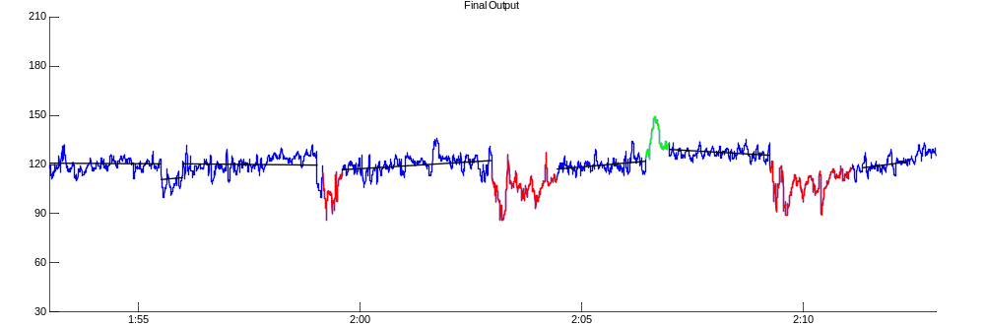
Figure 1: Tracing segmented into baselines, accels and decels

The overall process of feature detection is shown in Figure 2. Some changes have been made from the original MATLAB prototype. A Bump Extension stage has been added, and a separate Merge stage has been included. The merging process was previously considered part of bump classification, but complications introduced in a realtime environment increased merging complexity enough to warrant separate consideration. We can also see that all baseline candidates (i.e. the output of baseline detection) are used for final output merging, as opposed to just the set classified as baselines by multiHypothesis. Multihypothesis baselines are still used as references for the purposes of bump extension and classification.

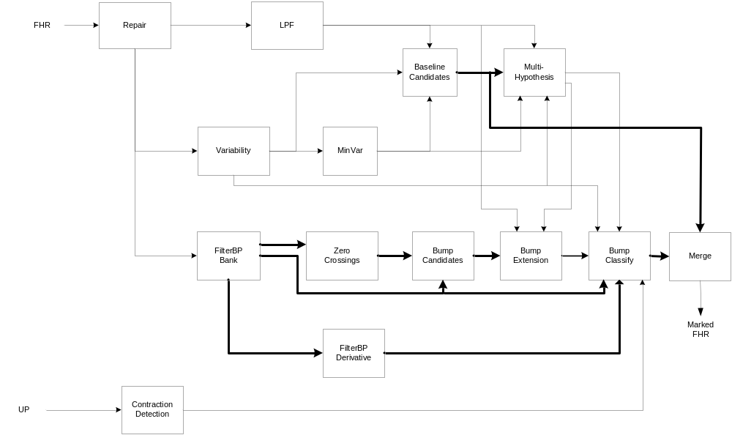
Figure 2: Overall Feature Detection

Repair
The repair module aims to remove any interference (maternal or otherwise) from the FHR signal, as well as fill in any FHR signal dropouts. It attempts to reconstruct a cleaner version of the FHR signal to facilitate feature detection by removing any abrupt changes in FHR signal level due to interference or loss of signal, and by interpolating short signal dropouts. All other modules use the repaired version of the input FHR signal. Figure 3 shows 20 minutes of raw FHR and the repaired version of the same signal, with repaired segments shown in red.

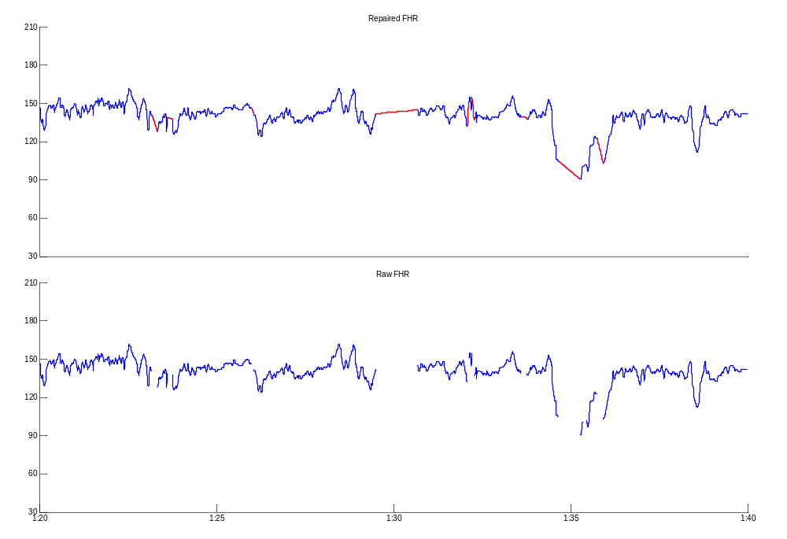
Figure 3: Raw and Repaired FHR signal

Preprocessing / Filtering
Since the features to be detected are of low frequency relative to the signal variation attributable to FHR variability, the first processing step is to separate the FHR signal into its low frequency and higher frequency components. This is done with a low pass FIR filter and a variability filter.

Low Pass Filter (LPF)

The Low Pass filtering step removes any higher-frequency (above 0.2 Hz) variability from the FHR, resulting in a smoothed-out version of the input signal, which facilitates certain search algorithms as employed in baseline detection and bump extension. An example of repaired signal (in blue) and its low pass equivalent (in red) are shown in Figure 4.

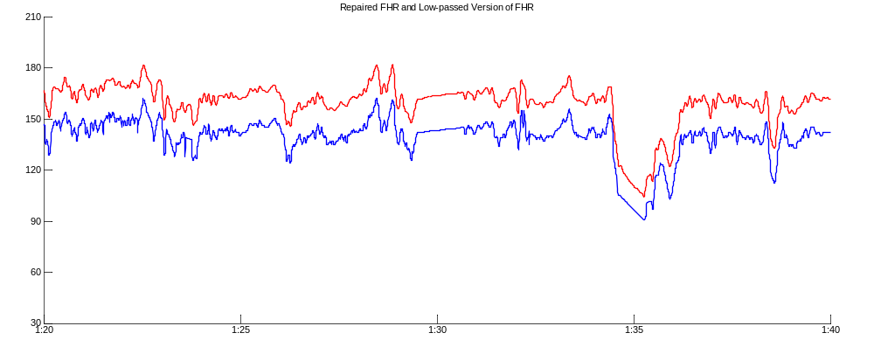
Figure 4: Repaired (blue) and Lowpass (red) FHR

Variability Filter (filterVar)
The Variability Filter measures the FHR variability energy by detecting the envelope of the high frequency component of the FHR. It is obtained by applying a band pass filter (which is essentially high pass) to the FHR signal, and full-wave rectifying the signal before low-pass filtering the result. The output of the variability filter represents a local estimate of the FHR variability, and is used to allow various modules to adapt to local conditions. This is useful for baseline detection (the definition of what constitutes a flat region is dependent on the ambient variability), multiHypothesis and classification of acceleration and deceleration candidates.

MinVar
The minVar signal is obtained from the output of the Variability filter, and is essentially a lower bound on the local variability. It serves as a more conservative, quantized variability estimate that is also used as input to the baseline detection, multiHypothesis and accel/decel classification modules. Figure 5 shows a repaired signal and the corresponding Variability filter and minVar signals.

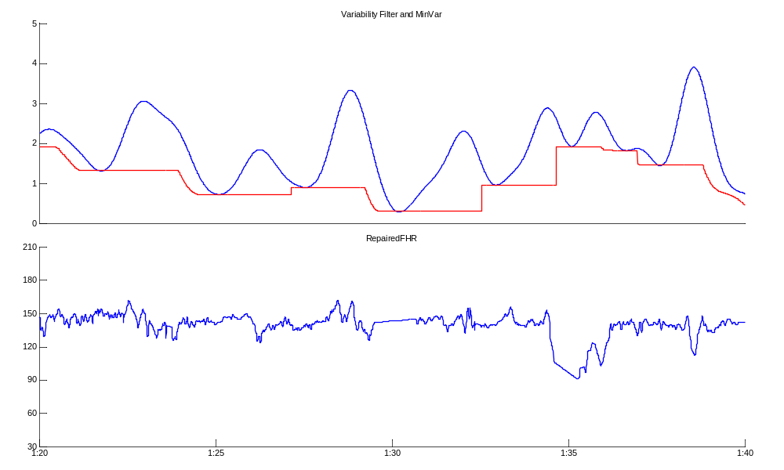
Figure 5: Variability Filter (blue) and minVar signal (red)

Baseline Detection
The Baseline Detection module attempts to segment the FHR signal into series of flat areas. The baseline detection algorithm operates on the low-passed version of the fhr and flatness is defined relative to the ambient variability (estimated by the minVar signal). Periods of high variability will allow for a looser definition of flat. The identified segments of flatness constitute a set of baseline candidates. These baseline candidates
serve as input to the multiHypothesis module, which separates candidates into actual baselines and non-baselines. Candidates identified as true baselines will then be used as a reference FHR level when classifying (and extending) acceleration and deceleration candidates. All baseline candidates are used in the final merge of output events, where several of these candidates will be truncated or overwritten by portions of tracing identified as accelerations or decelerations.

MultiHypothesis
The MultiHypothesis stage refines the set of baseline candidates, removing those that are deemed to be non-baseline (such as flat areas at bottoms of decels). This ensures a set of stable reference levels, which are important for accurately determining accel and decel boundaries (bump extension) and for accurate classification of acceleration and deceleration candidates.

MutiHypothesis uses a set of neural networks for classification, using surrounding baseline candidates and variability measures as input features for classification of a given baseline.

A set of baseline candidates is shown in Figure 6, with those classified as baselines by multiHypothesis shown in black, and those classified as non-baselines shown in red.
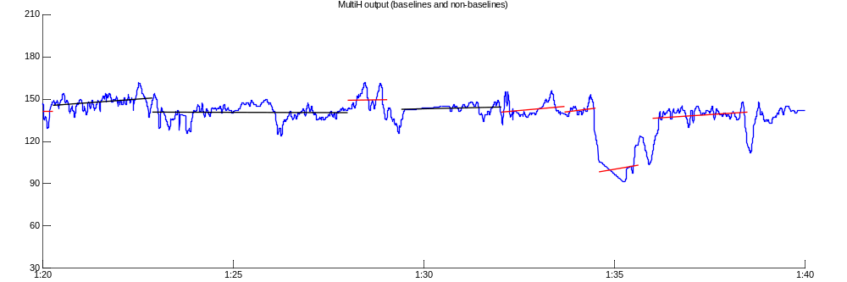
Figure 6: Multi-hypothesis classification of baseline candidates

Accel/Decel Classification
The Accel/Decel Classification stage detects bumps (accelerations and decelerations), which can be thought of as significant deviations from a baseline level either upwards (accel) or downwards (decel). This detection is done by first subdividing the FHR signal into multiple frequency bands and selecting bump candidates based on the zero-crossings of these band pass signals. These bump candidates are then classified as a true event (decel or accel) or non-event (non-decel, non-accel) based on a neural network classification that uses features measured from the candidate events (e.g. duration, depth, etc.).

Band Pass Filters (FilterBP Bank)
A set of bandpass filters subdivides the FHR signal into several frequency bands, allowing for the identification of signal energy at different frequencies, corresponding to different bump lengths. The realtime implementation uses 4 frequency bands (the original implementation used 6), the shortest of which has a pass band in the 25-40 second range and the longest of which has a pass band in the 90-200 second range. Each band pass filter targets the detection of decels and accels of lengths that are in or near the filter pass band.

Zero Crossings
The Zero-Crossings of the band pass signals designate the initial boundary estimates of candidate bumps. The areas of signal between any two Zero-Crossings in any band make up the initial set of bump candidates. An initial filtering of these candidates is done with minimum length and area thresholds. Band pass signals along with the original repaired signal are shown in Figure 7. Green segments become accel candidates while the red ones become decel candidates. The set of candidates across all bands will be reduced through the bump competition stage.

Bump Competition (Bump Candidates)
The bump competition stage compares overlapping candidates from different frequency bands and selects the one with the highest energy. Accels and decel candidates are considered separately and the bump competition ensures that only one bump candidate of a given type (accel or decel) is considered at any given time (i.e. there is no overlap between candidates of the same type). These bump competition winners then make up the set of candidates that will be extended, and then classified by the neural network. Bump competition winners for both accels and decels are shown along with the corresponding band pass signals in Figure 7.

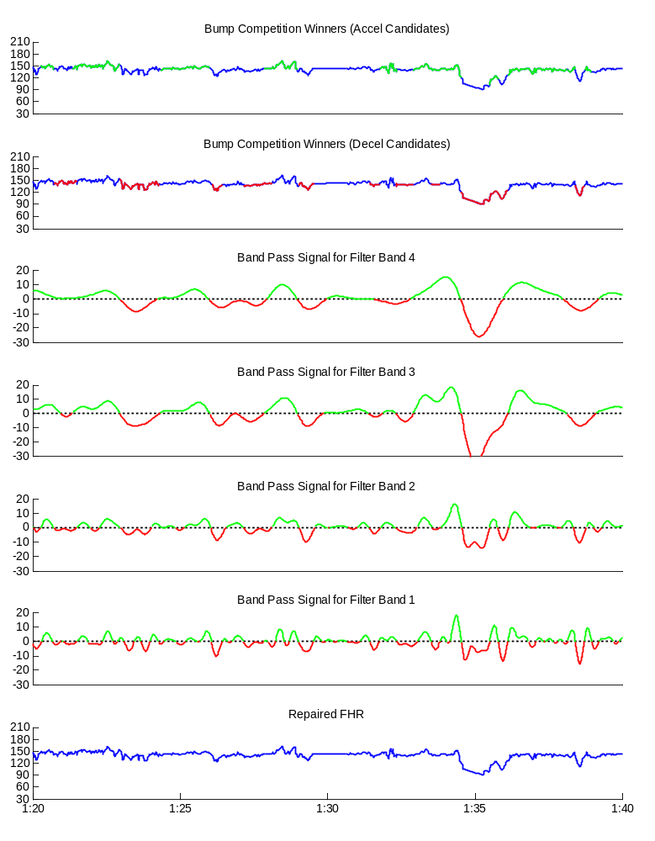
Figure 7: Band Pass Signals, Zero Crossings and Bump Competition

Bump Extension
In some cases, especially with large and/or deep decelerations, boundaries of bump candidates can be underestimated. The bump extension stage attempts to find more accurate bump candidate boundaries, using a time-domain ‘hill-climbing’ algorithm on the low pass version of the FHR signal. Original and extended versions of decel and accel candidates are shown in Figure 8 and Figure 9 respectively.
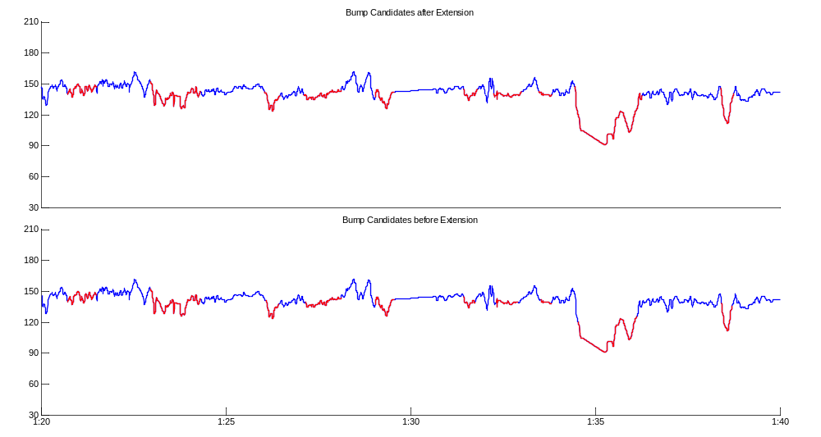
Figure 8: Bump Extension of decel candidates

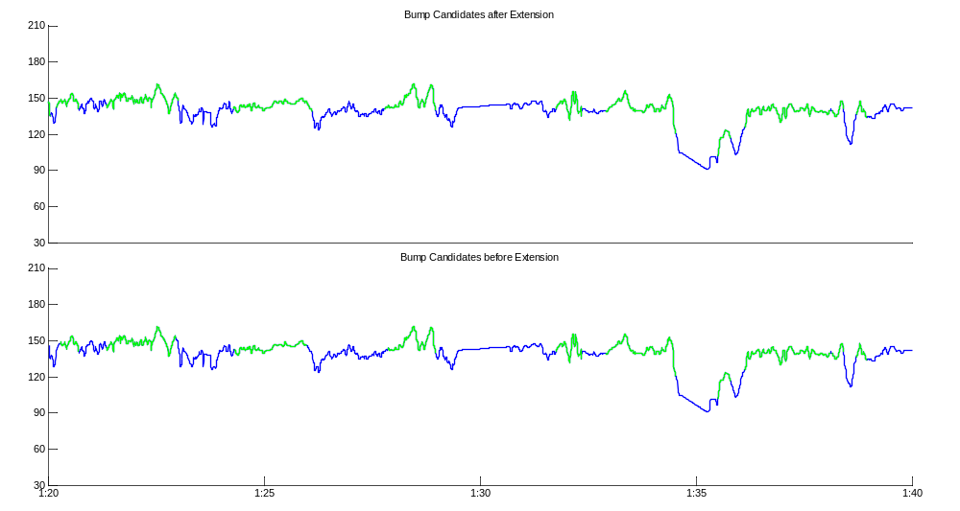
Figure 9: Bump Extension of accel candidates

Bump Classify
The bump classification stage takes the extended bump candidates and classifies them as true events or non-events, using a neural network. Each accel candidate is classified as either an accel or a non-accel while decel candidates are classified either as a non-decel, a gradual decel or an abrupt (variable) decel. An abrupt decel generally has a steeper slope and greater depth than a gradual decel, which tend be be faily shallow and symmetrical. Gradual decels are further sub-classified as early, late, non-associated or indeterminate based their timing relationship (or lack thereof) with an associated contraction.

Classification is done based on multiple features, such as a reference baseline level before and after the bump, the mean and maximum bump height, the ambient variability, and the bump lengths, among others. The classification results of the extended candidates shown earlier are shown in Figure 10 for decels and Figure 11 for accels. Candidates classified as gradual decels are shown in solid cyan (light blue) while abrupt decels are shown in solid red. Candidates classified as non-decels are shown with a dotted red line. Candidates classified as accels are shown in solid green while non-accels are shown with a dotted green line.

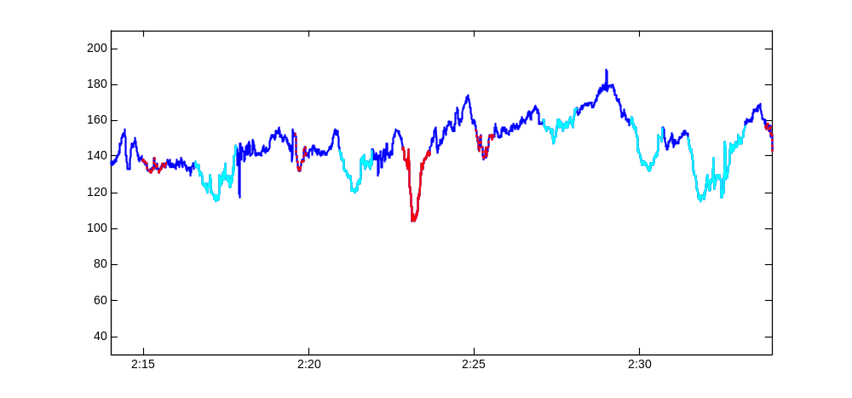
Figure 10: Classification of Decel Candidates

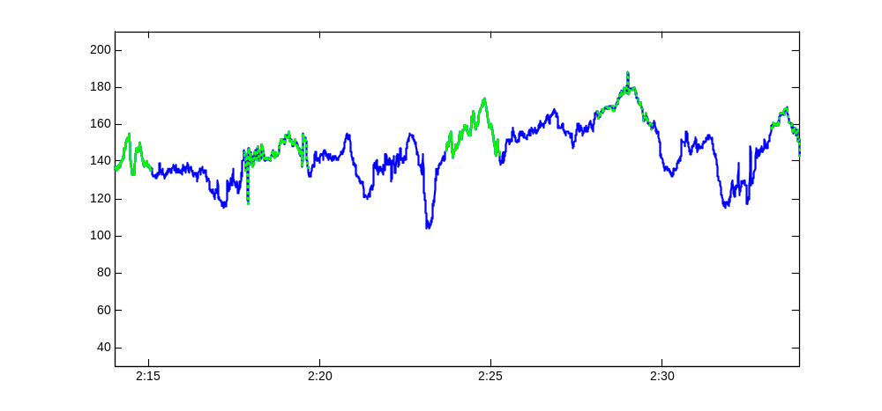
Figure 11: Classification of Accel Candidates
Decel candidates are classified before accel candidates, and accel candidates are then modified based on overlap with decel candidates classified as decels - accel candidates are truncated where there is overlap with a decel. Any resultant accel candidates that are less than 15 seconds in length or 15 bpm in height are then discarded, prior to classification.

Merge
The merging process combines the baseline candidates found in the baseline detection module, and the accels and decels classified as true events in the Bump Classify stage. For overlapping parts, decelerations take precedence (overwriting or truncating overlapping accels and/or baselines) while accels take precedence over baselines. The output of baseline detection is used (as opposed to that of MultiHypothesis) because most non-baselines are overwritten by decels and accels, and this method provides the greatest coverage of true periods of baseline. Baseline candidates (in black), classified accels (in green), classified decels (in red) and their merged output are shown in Figure 12.

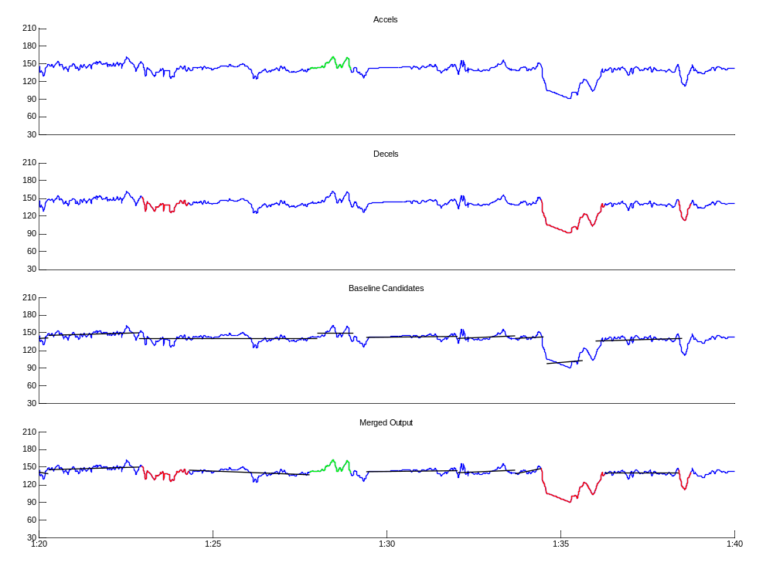
Figure 12: Merge of final output events

Realtime Implementation

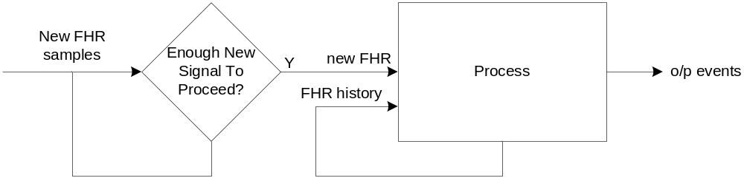
Figure 13: Realtime flow

The realtime implementation of Patterns works by processing overlapping windows of FHR at regular intervals. Each overlapping window consists of newly received FHR signal and a signal history of FHR.

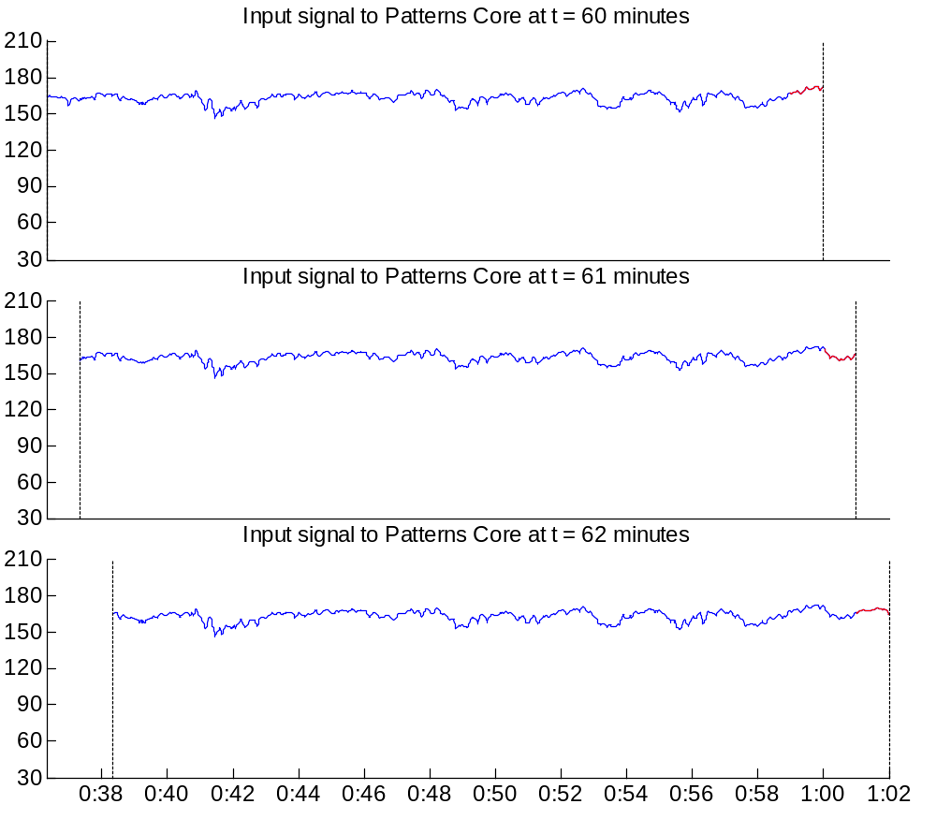
Figure 14: 3 Consecutive signal windows w/ BS = 240 samples

The block size, BS, is defined as the amount of signal that is appended between processing iterations. The window size, WS, is a function of the required signal history and the block size. Figure 14 shows three consecutive signal windows with WS equal to 5682 samples, and BS equal to 240 samples (1 minute). Newly appended signal is shown in red.

Classification of an output event requires a certain amount (typically about 5 minutes) of future signal, resulting in an equivalent delay. This delay is mostly attributable to the band pass filters used for accel/decel detection. The longest such delay (for band 4) is approximately 4 minutes. This is the minimum delay on any given output event. Additional delay is required to ensure stability on output events. This stability delay is not fixed and depends on the characteristics of the tracing in the current window, but is generally in the range of 0-2 minutes. These delays will be discussed in greater detail when discussing accel/decel detection and merging.

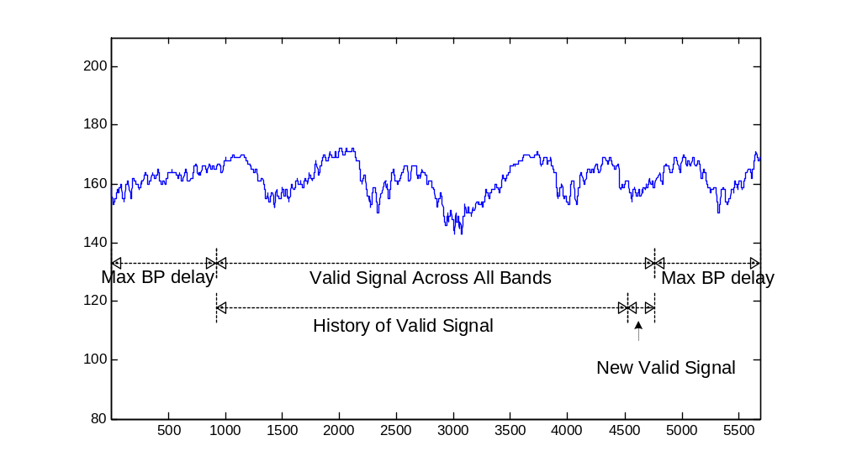
Figure 15: Signal Window
A portion of the required signal history (and thus WS) is to compensate for filter delays. When WS samples of FHR signal are filtered, each filtered version of the signal will only be valid from samples d_{f} to WS – d_{f} , where d_{f} is the filter delay. The window size thus needs to be large enough such that there is enough valid signal across all filtered signals in the window. In this case, the longest filter delay (band pass 4) dictates the amount of signal history required to compensate for filter delay.

The remaining required signal history is a function of the longest possible pre-extension bump candidate length (7.5 minutes). This will be discussed in more detail in the bump competition section. The total required signal history can be summarized as:

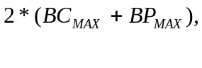
where BC_{MAX} is the longest possible pre-extension bump candidate length, and BP_{MAX} is the longest band pass filter delay. We define MAX_DELAY as the sum of these two terms:


We can then define the window size as:



Using a maximum pre-extension bump candidate length of 7.5 minutes, a band pass 4 filter delay of 919 samples and a default block size of 240 samples, this gives us a window size of 5682 samples, or 23 minutes and 40.5 seconds at 4 Hz. The selection of the longest possible bump candidate length was done based on an analysis of bump candidates across 6 bands (as opposed to 4).

During development, a block size of 1 minute (BS=240 samples) was used. In practice, the block size can be chosen to be any length, and need to not be fixed over the course of a tracing. A smaller block size will result in a greater computational load (as processing iterations occur more frequently) but can provide a more frequent refresh of output events.

From Figure 14 we can see that under default conditions, only a small portion of the signal window is actually new signal – the portion of overlap with prior windows is significantly greater. Modules (such as repair, baseline detection, accel/decel) have some memory from window to window, such that redundant computations are not performed over overlapping signal at each processing iteration. Even so, every module will still have to operate on some variable amount of minimum overlapping signal, depending on the module and the signal characteristics. These memory mechanisms will be discussed on a module-by-module basis.

Repair
The repair module identifies segments of interference (maternal or otherwise) and dropout from the FHR tracing, and provides a predicted replacement signal for these segments, by interpolating between portions of signal that are known to be valid.
Dropout refers to be periods where there is no signal, while other artifact refers to periods of tracing where the signal is considered invalid due to interference from another source. These two scenarios are considered separately.

Dropout
A dropout is defined as a portion of tracing with no signal. Dropout is assumed to be signalled to Patterns by sample values of zero. Once a dropout is identified, the following steps are taken:

1) Find true start point of dropout
In some cases, there will be one or more samples of invalid signal immediately prior to a dropout. These are identified by large jumps in FHR immediately prior to dropout. This step ensures that the sample prior to the dropout to be used as a reference is indeed valid fhr.

2) Define artifact entry parameters:
lastGoodFhr: the value of the sample prior to the true start of the dropout
currSlope: the slope of the fhr signal for the 2.5 seconds prior to the start of the artifact

3) Determine the end of the dropout period
The potential end of a dropout period is discovered when there is an FHR value that falls between a minimum (nominally 60 bpm) and maximum (nominally 190 bpm) value. These minimum and maximum FHR thresholds can be respectively lowered or raised if the value of lastGoodFhr is near one of those limits.

Given a potential dropout end, we first try to find the true return from dropout by looking at samples immediately prior. The true return from dropout can be earlier in cases where there is valid signal that is less than 60 bpm or greater than 190 bpm, and the return from dropout was initially identified only when the signal crossed one of those thresholds into the ‘valid’ FHR range. Once the true return from dropout is identified, the following parameters are calculated (where t₁ is the time of the last valid fhr sample prior to the dropout and t₂ is the time of the potential end of the dropout):

dropoutLength: the amount of time between the last good FHR value and the potential end of dropout (t₂ - t₁ - 1)
sigTime: the amount of time before the next dropout after t₂

These parameters are used to determine whether the potential return from dropout is actually valid signal, and are shown graphically in Figure 16.

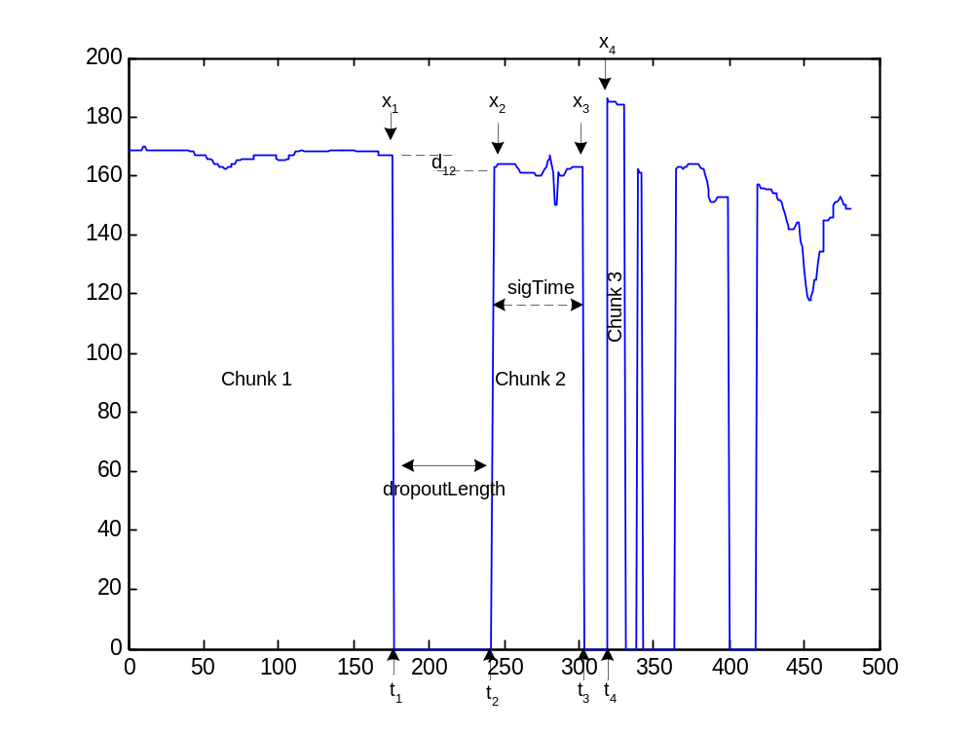
Figure 16: Dropout Parameter Definitions
Below we examine various scenarios in determining whether a repair should be made between a pre-dropout signal chunk (Chunk 1 in Figure 16) and a post-dropout signal chunk (Chunk 2 in Figure 16) or whether the post-dropout signal chunk should be considered invalid signal. We define x₁ as the FHR value at time t₁ (x₁ is also known as lastGoodFhr) and x₂ as the FHR value at time t₂. The pre-dropout signal chunk will be referred to as Chunk 1, while the post-dropout signal chunk will be referred to as Chunk 2.

Scenario A) dropoutLength <= 3 seconds

If a dropout is very short in duration, we will assume that the post-dropout signal chunk is valid if the difference in signal level between the last valid FHR value and the value of the first sample in Chunk 2 is relatively small. The duration of Chunk 2 (sigTime) is also taken into consideration (we will accept a larger difference in FHR values for a larger sigTime). The flow diagram in Figure 17 shows the decision making process for short (less than 3 second) dropouts, where d₁₂ represents the time between the end of Chunk 1 and the start of Chunk 2.

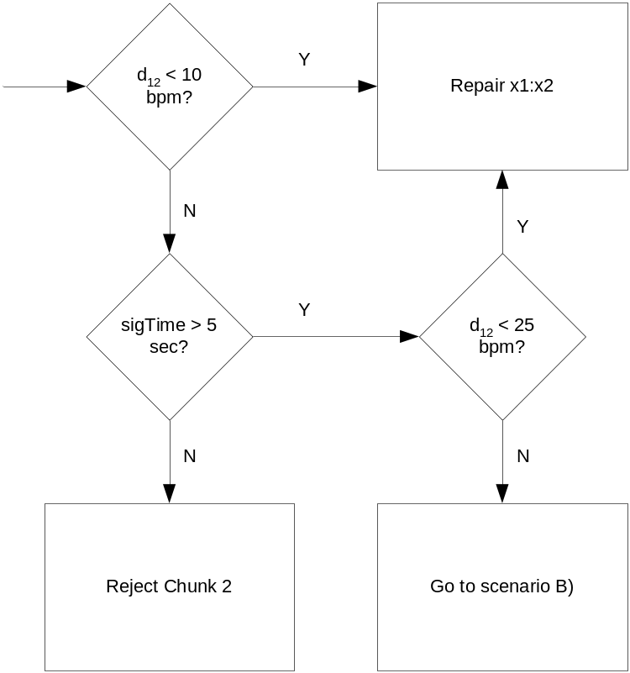
Figure 17: Flow Diagram for Short Dropout (Scenario A)

A repair between x1 and x2 simply means to do a linear interpolation (i.e. draw a straight line) between samples x1 and x2. A rejection of Chunk 2 means to consider all of Chunk 2 as invalid signal, and move on to the next Chunk in the search for a valid return from dropout.

Figure 18 shows an example where a succession of short dropouts/chunks are accepted as valid signal because the difference in FHR level is very small. Figure 19 shows an example of a dropout and return with a larger difference in FHR level that is accepted due to the long duration (sigTime) of the post-dropout signal chunk.

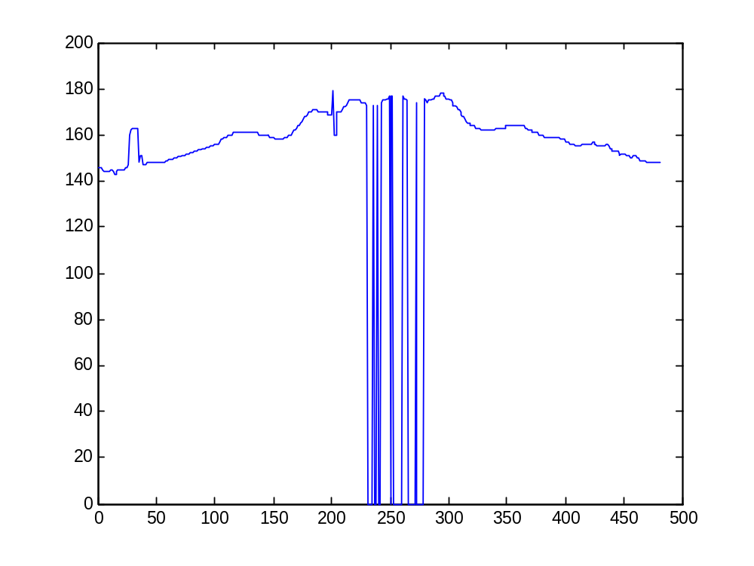
Figure 18: Succession of short dropouts
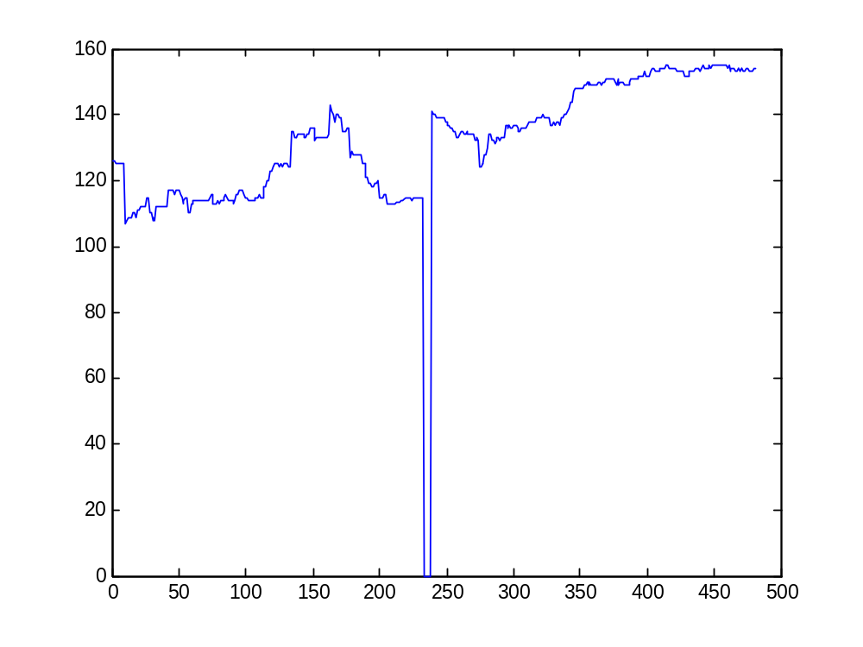
Figure 19: Short dropout w/ substanstial FHR jump followed by long signal chunk (Scenario B)
In cases where the dropout is longer than 3 seconds, or the post-dropout signal chunk is at least 5 seconds in length and the jump in FHR level is substantial (see Figure 17), we also consider the slope between x1 and x2 (entry slope), and in some cases the slope between x3 and x4 (exit slope), when trying to determine if the post-dropout chunk is indeed valid signal.

The maximum entry slope (and exit slope) is parametrized by the signal slope prior to dropout (i.e. at the end of Chunk 1). If the signal was sloping downwards prior to droupout, we will accept a larger negative slope between x1 and x2. Similarily, if the signal was sloping upwards prior to dropout, we will accept a smaller downward slope. These threshold slopes are parametrized as follows:

max_pos_slope = max{1.5, 2 + (5 * currSlope)}
max_neg_slope = max{1.5, 2 – (5 * currSlope)},

where currSlope is the slope at the end of Chunk 1 and is negative if sloping downwards. A minimum value of 1.5 is used regardless of the entry slope to avoid rejection of valid signal due to poor estimations of the slope prior to dropout. The entry slope is calculated as:

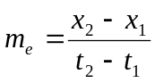

The exit slope, if Chunk 3 is deemed valid, is calculated as:

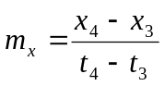

If the entry slope fails, short (less than 20 second) signal chunks are rejected but longer chunks are trimmed and retested for slope. This is to ensure against erroneously considering valid signal as dropout for any significant amount of time. As samples are trimmed from the start of a signal chunk, sigTime is recalculated, and if the chunk eventually becomes less than 20 seconds in length and is still failing the slope criteria, then it is rejected. However, if there is a scenario where the slope fails and Chunk 2 is actually a large portion of valid signal (i.e. several minutes long) then only a short segment at the start will be erroneously classified as invalid (this was one of the situations where problems occurred in the original repair algorithm).

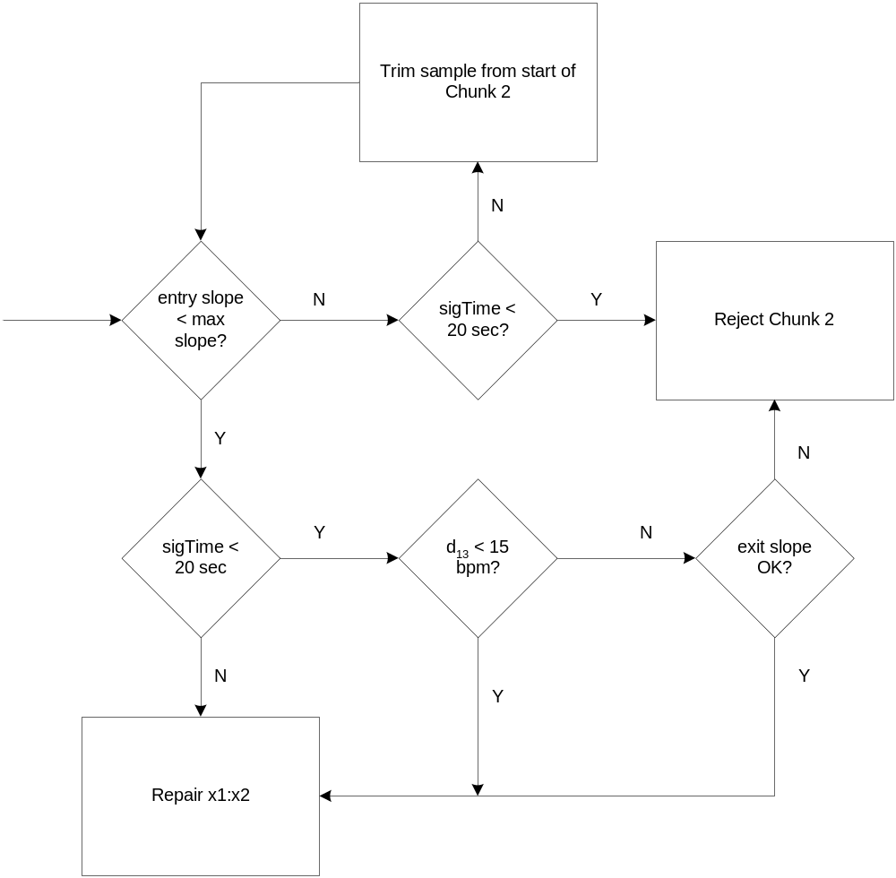
Figure 20: Flow Diagram for longer dropouts

If the entry slope is within limits, then the signal chunk is accepted as valid signal and a repair is performed. Otherwise, if there is a substantial (greater than 15 bpm) difference in FHR level at the end of the Chunk from the last known good FHR level, then an exit slope check is performed.

In order to check the exit slope, we need to find the ensuing signal chunk. For the ensuing chunk to be of interest and valid, it must not start more than 5 seconds after the chunk currently under consideration, be at least 5 seconds in length, and have a level no more than 15 bpm different from the last know valid FHR level. The purpose of this exit slope check is to find portions of signal that are clearly maternal interference bordered by short dropouts. An example of such a scenario is shown in Figure 21.

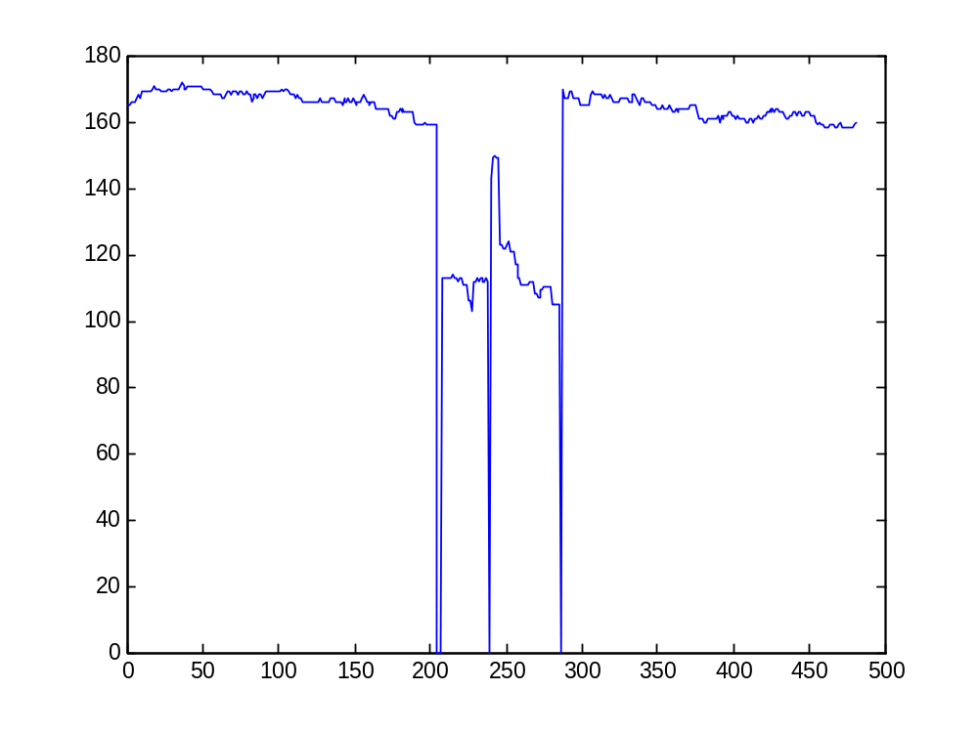
Figure 21: Maternal Interference bordered by short dropouts

Other Artifact

Other artifact are defined as portions of tracings that are not valid FHR signal, but where the signal value is deemed to be erroneous due to interference from another source. Maternal interference is the most common cause of other artifact. The short blip in the middle of the 5 minutes of tracing shown in Figure 22 is an example of other artifact that is not maternal interference.

Other artifact presents greater difficulty in accurately and precisely identify starts and ends of artifact segments; one result of over-detection is the rejection of valid sharp decels as some form of signal interference

A possible artifact start is flagged when the difference between two successive samples is 20 bpm or greater. Once a potential artifact entry point is discovered, a more accurate potential start point is found, by looking for sample-to-sample jumps of more than 10 bpm immediately prior. A check is then done to ensure that this potential artifact entry is not actually the beginning or end of a sharp decel.

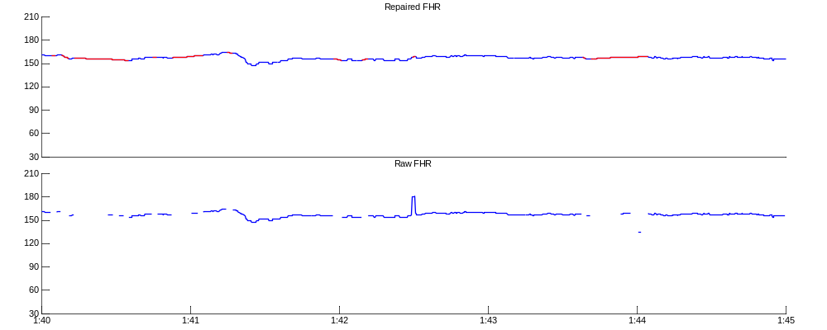
Figure 22: Example of other artifact (Original and Repaired signals)

Once a potential artifact entry point is confirmed as probable, a best possible artifact exit point is searched for in the ensuing 15 seconds. Artifact regions greater than 15 seconds will be dealt with in segments. This maximum artifact length protects against ‘runaway’ repairs that end up throwing away potentially large section of valid signal.

A best artifact exit point is found by comparing the difference between the last known good FHR value (immediately preceeding the artifact) and subsequent FHR values occuring after the artifact start. There exists two separate difference metrics for determining the most suitable exit point. The first (slopeDiff) takes into account the signal slope immediately prior to the artifact start (currSlope), and measures the difference between a given sample and the extrapolated line (with slope currSlope) from the last good FHR value. The second (absDiff) simply uses the absolute difference between a given sample and the last good FHR value.

In general, the slope difference metric (currSlope) is preferred to the absolute difference for determining a suitable artifact exit point, but in cases where the best absolute difference is significantly lower than the best sloped difference, the absolute difference may be used for determining exit points. This guards against exit points based on poor slope estimates in signal immediately prior to the identified artifact. Figure 23 shows a magnified version of the artifactual blip shown in Figure 22, with the sloped extrapolated line (in dotted red) and the corresponding values of the two difference metrics over time.
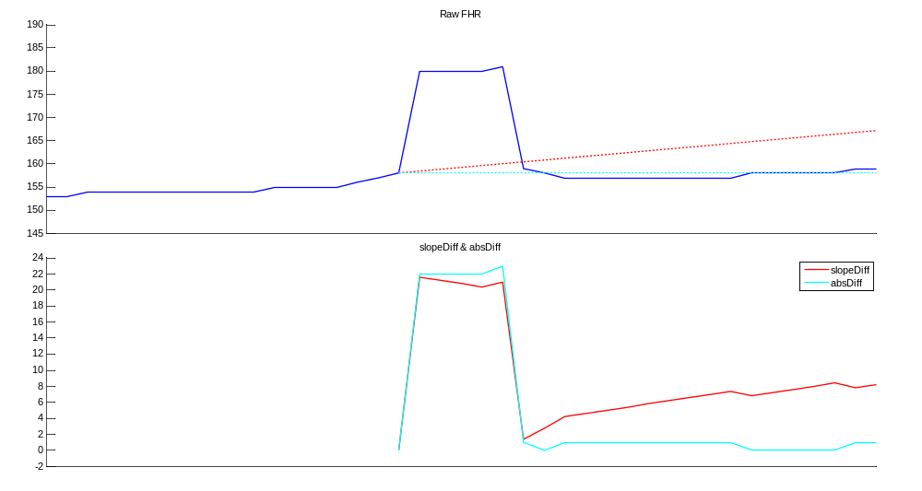
Figure 23: Difference metrics for finding exit point of artifact

In general, short repairs are favoured over long repairs. The first search for an artifact exit point thus only considers the 3 seconds immediately following the beginning of an artifact. If either of slopeDiff or absDiff is less than 5 bpm in the first 3 seconds after the start of an artifact, then a short repair is immediately made to that point, without searching any further.

If neither difference metric is less than 5 bpm in the first 3 seconds following the artifact start, then the entirety of the 15 seconds following the beginning of the artifact is searched. The minimum values (and corresponding sample indexes) of the two difference metrics are found (minSlopeDiff, minAbsDiff) and these are used to determine the best possible exit point. If the minSlopeDiff is less than 12 and is less than twice as large as minAbsDiff, then it is used to determine the artifact exit point. If minAbsDiff is less than half of minSlopeDiff and is less than 12, then it is used to determine the artifact exit point.

If there is a dropout in the 15 seconds following a detected artifact start point, and neither of minAbsDiff or minSlopeDiff is less than 12, then the artifact is treated as a dropout, and the criteria for finding a suitable return from dropout are used instead.

In cases where both difference metrics are greater than 12 and there is no dropout, then the index where minSlopeDiff occurs is chosen as the best exit point of the artifact. These cases usually only occur during periods of chronic signal interference, in which case the signal is generally not interpretable.

A flow diagram detailing the search for artifact exit point is shown in Figure 24, where x1 refers to the index of the last valid FHR value, and x2 is iniatially equal to x1 + 1.

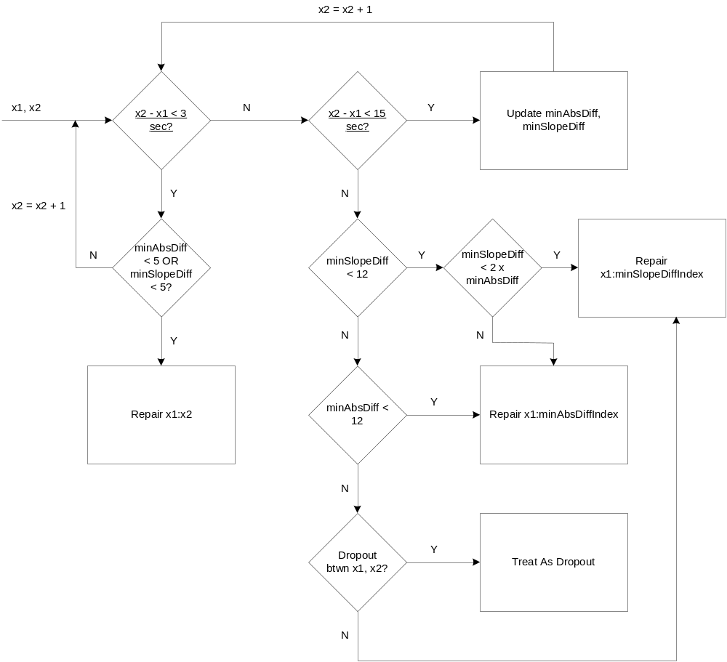
Figure 24: Finding artifact exit point

Repair Intervals
When a repair is made, the start and end indexes of the repair segment is stored, such that other modules will explicitly know where the signal has been repaired. This allows periods of significant repair to be ignored when detecting baselines, and allows for the rejection of accel or decel events that contain excessive artificial signal.

Real Time Considerations
In general, only signal that has been appended since the last processing iteration (BS samples) need be considered for repair. Prior signal should have already been repaired in a prior processing iteration. However, if a repair is applied near the end of the available signal in the window, it may be unstable, in that it could change depending on future signal. In these cases, a marker (m_NextRepairStart) is used to identify the last known stable repair index and repair is started from this point in the next processing iteration. This marker also identifies the end of valid repaired signal so that other modules (baseline detection, accel/decel) only consider events based on valid and stable signal.

The most basic case of unstable repair occurs when there is a dropout at the end of the signal window. In these cases the last known good fhr value is simply held, and the repair process in the ensuing window is started from the sample index of that last known good value. This case is shown graphically in Figure 25. The repaired signal at the end at the window at 165 minutes is unstable since we have not yet arrived at a return from dropout. When we do find a return from dropout in the ensuing window (166 minutes) we can perform the repair.

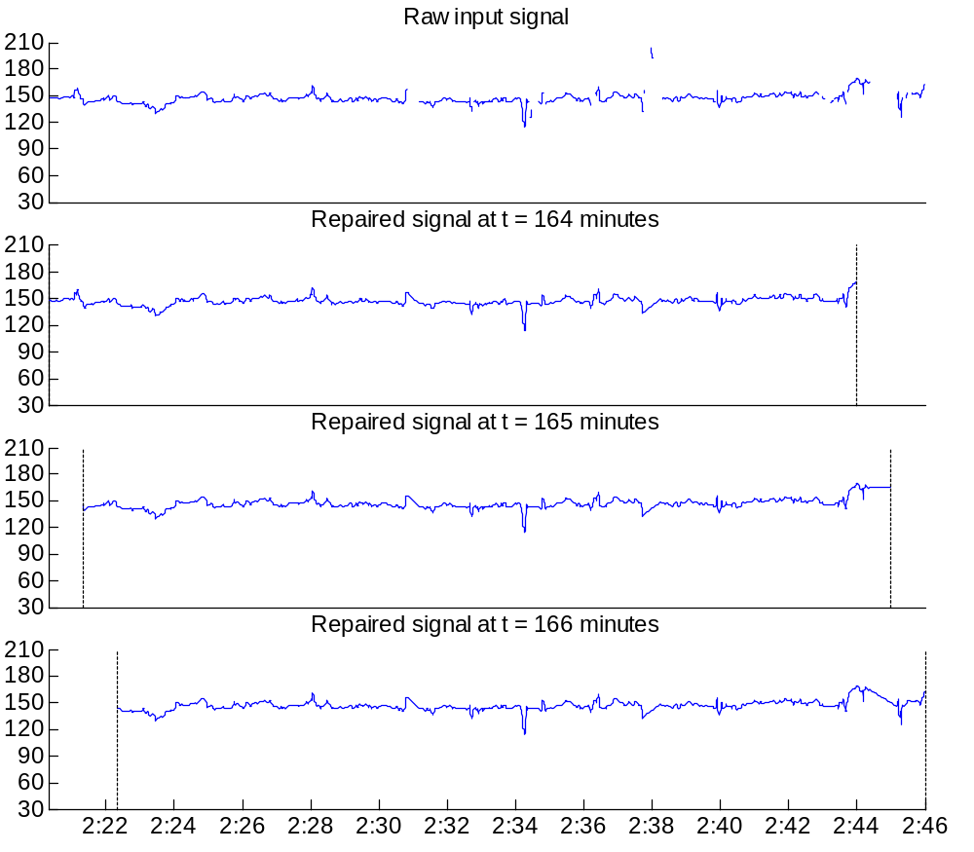
Figure 25: Repair output for 3 consecutive windows

Less obvious cases of repair instability can also occur, and in general if there is a dropout or a possible other artifact (any bpm jump of 20 or more) in the last 30 seconds (120 samples) of raw signal, then the end portion is flagged as ‘potentially unstable’ and will be re-repaired in the ensuing processing iteration when there is more signal available. Any ‘potentially unstable’ repair region will not be considered for baseline or bump candidates in the current iteration.

Preprocessing / Filtering
The preprocessing and filtering blocks are defined as the low pass filter (LPF in Figure 2), the Variability filter (Variability in Figure 2), also known as filterVar, and the minVar signal, which is derived from the variability signal. The low pass and variability filters separate the FHR signal into low and high frequency components.

Low Pass Filter
The low pass signal removes any high-frequency (above 0.2Hz) content, providing a smoothed-out version of the FHR signal, with any short-term fluctuations attributable to FHR variability removed from the signal. The low-pass version facilitates search algorithms used in baseline detection and bump extension.

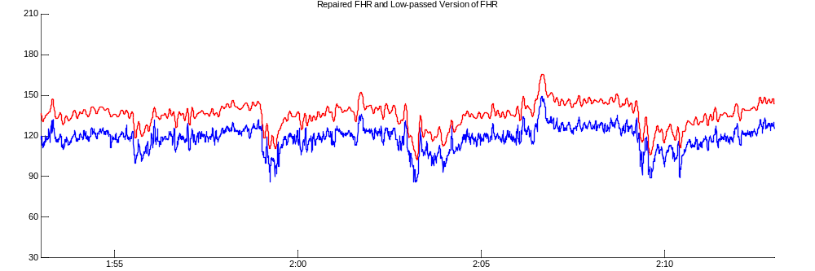
Figure 26: Repaired and LowPass versions of FHR

The low pass filter (fir_filt2) was implemented as a Direct-Form II FIR filter with specifications as follows:

- Pass Band: 0.15 Hz
- Stop Band: 0.2 Hz
- Pass Band Ripple: 2 dB
- Stop Band Attenuation: 70 dB,

which results in a filter with order 162, resulting in a filter delay of 81 samples or 20.25 seconds at 4 Hz.

The frequency response of the low pass filter is shown in Figure 27.

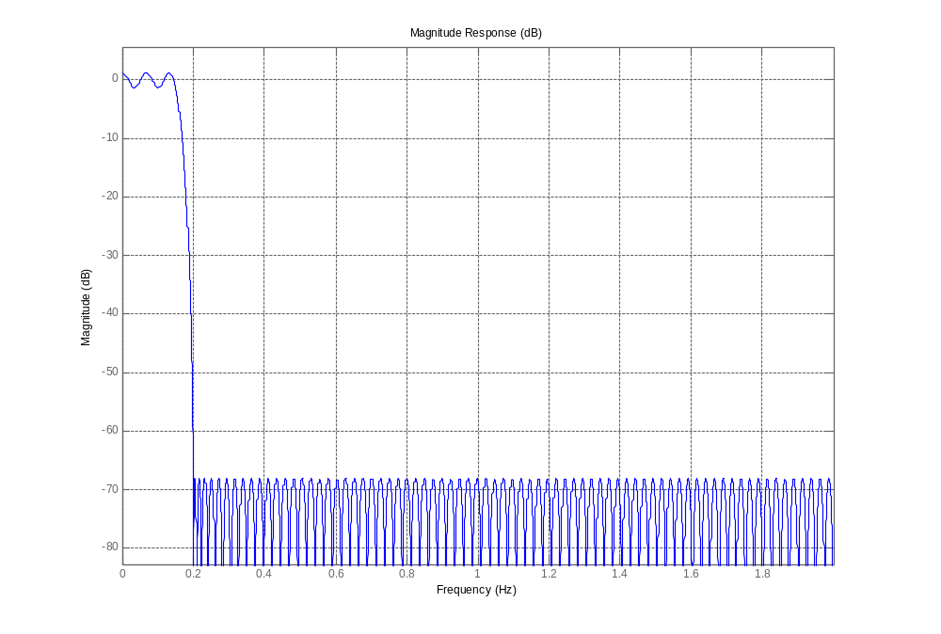
Figure 27: Low Pass Filter Frequency Response

Variability Filter
The variability filter provides an estimate of the short-term variability of the FHR signal. It is obtained by applying a band pass filter (that is essentially high pass in nature) to the repaired FHR signal, full-wave rectifying the band pass version, and then low pass filtering the result, giving an envelope of the relatively high frequency component of the signal.

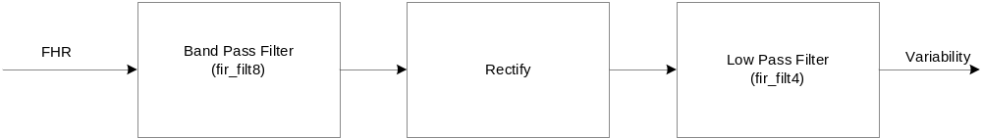
Figure 28: Variability Filter

The different stages of the Variability filter process are shown graphically in Figure 29, with the band pass signal shown in dotted red, the rectified version of the band pass signal shown in blue, and the low pass version of the result shown in black.

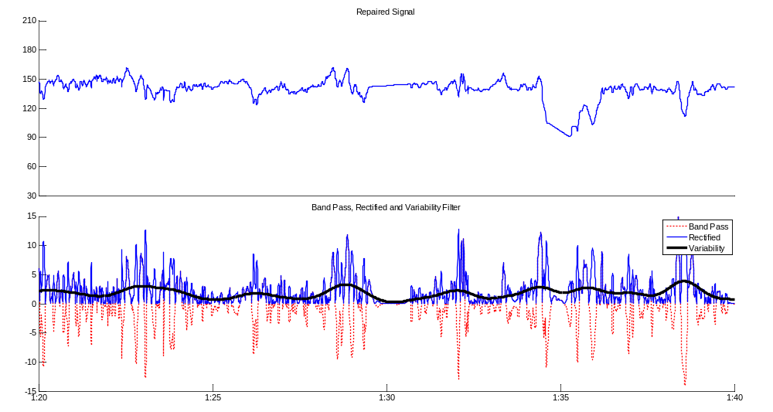
Figure 29: Variability Filter Stages

The band pass and low pass filters that make up the variability filter were both implemented as Direct-Form I FIR filters with specifications as shown in Table 1.

Table 1: Filter Var Specifications
Name | Type | Pass Band 1 (Hz) | Pass Band 2 (Hz) | Stop Band 1 (Hz) | Stop Band 2 (Hz) | Pass Band Ripple (dB) | Stop Band Atten. (dB) | Order | Delay at 4HZ (sec)
fir_filt8 | BP | 0.04 | 0.6 | 0.0001 | 0.65 | 2 | 70 | 202 | 25.25
fir_filt4 | LP | 1e-009 |  | 0.02 |  | 1 | 70 | 451 | 56.25

The frequency response of the band pass filter is shown in Figure 30.
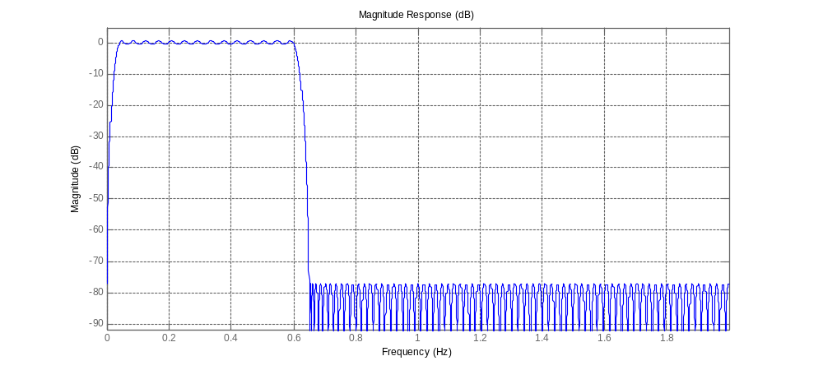
Figure 30: Frequency Response of Band Pass Filter used for Variability filter

MinVar
The minimum variability (minVar) signal is derived from the output of the Variability signal. Conceptually, the minVar signal at a given time is equal to the value of the closest local minimum in the Variability signal and can be thought of as the signal floor of the Variability signal.

In a realtime scenario, a limited 30 second lookahead is used, resulting in the minVar at a given time being equal to the last local minimum in the Variability signal, unless the next local minimum is less than 30 seconds in the future. In cases where the Variability at the current sample index is less than the previous local minimum, the minVar signal will follow the Variability signal.

The relationship between Variability and minVar is shown in Figure 31, with the Variability signal shown in blue and the minVar signal shown in red.

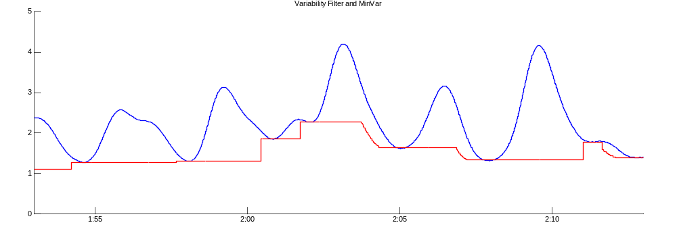
Figure 31: Variability Filter and MinVar

Dealing with Repaired Segments
Because repaired segments will have little or no mid or high-frequency content (as they will be a straight line), they should not be considered when generating the variability signal, as they will result in an artificially low variability values and potentially provide misleading features for baseline and accel/decel classification.

For small (less than 5 seconds) repair segments, the Variability signal can simply be interpolated over that repair interval. While the repaired signal does technically affect surrounding Variability samples, the effects of a small repair can be considered negligible. In order to consider Variability signal that is fully derived from ‘real’ signal, one would have to consider a buffer of signal on each side of the repair interval, equal to the length of the filter delay (total delay for Variability filter is 327 samples). However, experimentation showed that Variability signal that is more than half of the filter delay (163 samples) removed from a repaired segment was little influenced by that repair segment.

For repair segments greater than 5 seconds, the corresponding samples in the Variability signal, along with a buffer of 114 samples on either side, are replaced by a linear interpolation between Variability signal samples on either side. This ensures that repaired segments are not erroneously considered as period of low ambient variability. Figure 32 shows repaired FHR (with repaired segments shown in red) and the corresponding Variability signal. The blue Variability signal is the version that does not consider repaired segments, while the red version show the interpolation of repaired intervals and the appropriate buffer.

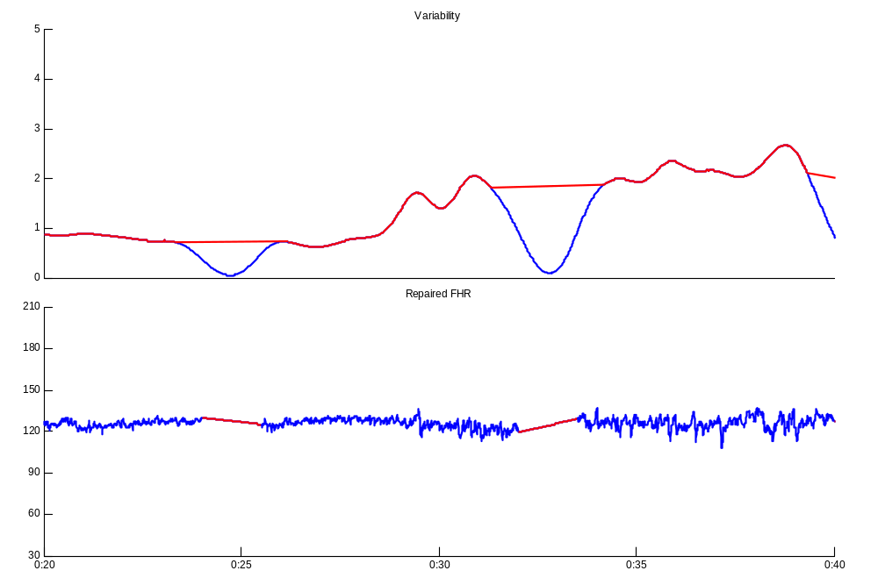
Figure 32: Interpolation of Repair in Variability Signal

Because the minVar signal is derived from the Variability signal, no additional considerations need be taken to filter out the effects of repaired signal from the minVar signal.

The lowpass signal is not modified based on repair intervals.

Realtime Considerations
Filtering (this includes the low-pass filter, variability filter, minVar as well as all band pass filtering used for accel/decel detection) is currently not done in a true realtime fashion. There is no memory from one window to the next; all of the signal in the window is refiltered at each processing iteration. This is an area where efficiency could be improved, although reprocessing each iteration does reduce memory requirements (one would have to save a copy of each filtered signal between processing iterations), and in general the filtering operation is not expensive.

Low Pass Filter
The low pass filter has a filter delay of 81 samples. This means that the first 81 samples of low pass signal in the window are invalid, and that there are 81 less samples of the low-pass version of the FHR than there are raw FHR. Any module using the low-pass version of the FHR (baseline detection, bump detection) therefore has a minimum inherent delay of 81 samples.

Variability Filter
The variability filter has a delay of 326 samples (81.5 seconds at 4Hz). Again, this means that the first 326 samples of the filtered signal are invalid, and that there are 326 less samples of the variability filter signal than there are raw FHR.

MinVar
Since the minVar signal is derived from the variability signal, and there is a delay of 326 samples on the variability signal, the end of the minVar signal in a given window holds the value of the last known local minimum of the variability signal. In this way, there is no delay on the minVar signal and it does not constitute a delay bottleneck in other modules, specifically baseline detection. Because the derivation of the minVar signal also has a look-ahead of 30 seconds (120 samples), the last 446 samples of the minVar signal in a given window are subject to change based on future input signal.
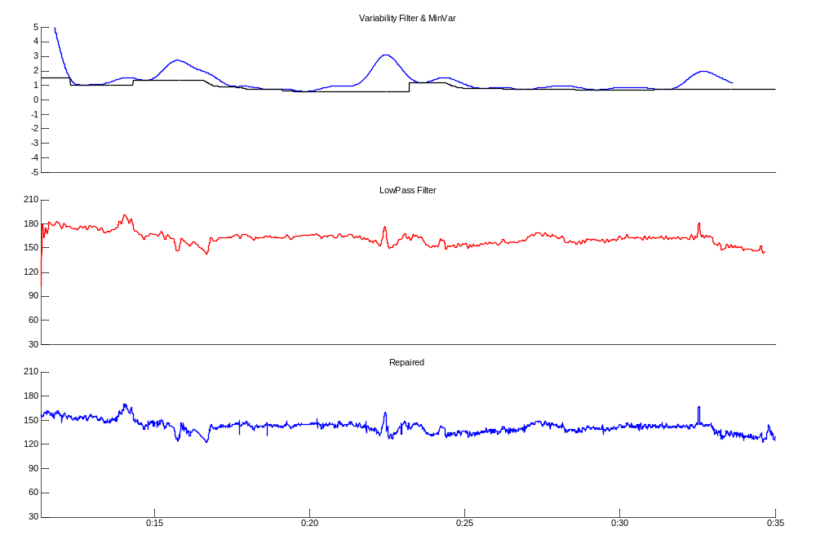
Figure 33: Repaired, LowPass, Variability and MinVar in Window

Low Pass, Variability and MinVar Output for a given signal window are shown in Figure 33. The low-pass signal has 81 less samples than the unfiltered repaired signal. The variability signal has 326 less samples but the minVar signal (in black) is extended to the end of the signal window by holding the last valid value.

Baseline Detection
The goal of the baseline detection module is to identify and segment areas of relatively flat signal. This allowable flatness is parametrized by the ambient variability estimate (minVar). The baseline detection module operates on the low pass version of the FHR signal.

The areas of flatness found in the baseline detection stage make up a set of candidate baselines. The multihypothesis stage then aims to separate this set of candidates into actual baselines and non-baselines.

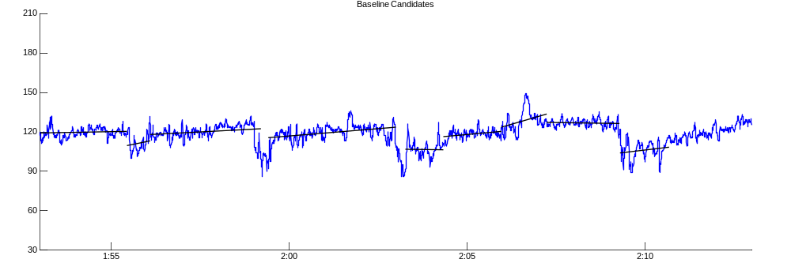
Figure 34: FHR signal segmented into baseline candidates

The core baseline detection algorithm was re-implemented since the MATLAB prototype and original Evonium C++ implementation. This new algorithm is based on the original, but has more streamlined and efficient search methods. Local variability estimates are updated during the search and use an average of begin, mid and end point minVar to provide more accurate and robust variability references.

Peak Detector
The baseline detection algorithm operates solely on the low pass version of the FHR signal. The first step is to identify local minimum and maximum (or extrema) in the low pass signal. The indexes of these extrema, and the midpoints between these extrema are used to speed up the subsequent search for baseline candidates. Extrema (in red) and extrema midpoints (in black) for a segment of low pass FHR are shown in Figure 35.

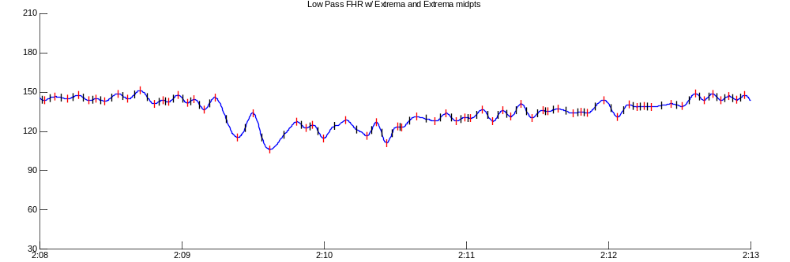
Figure 35: Extrema and extrema midpoints

CalcExtremaBoxes
The baseline search algorithm is based on fitting segments of low pass signal into a set of longest possible boxes. A box is defined as a parallelogram that contains all of a portion of signal within its boundaries. Boxes will have maximum allowable height, parametrized by ambient variability (minVar), and a maximum slope, parametrized by the box length. In addition, a box (and thus any baseline) must have a minimum length of 20 seconds.

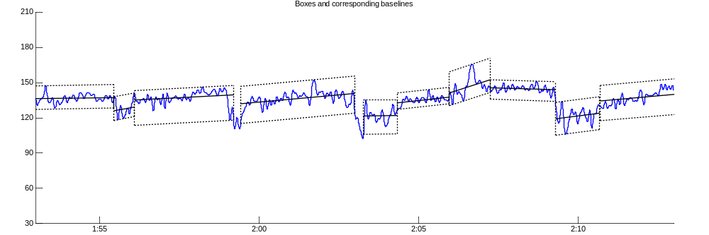
Figure 36: Boxes and corresponding baselines

The slope of a box is defined by the linear interpolation of the signal within the box boundaries. This linear interpolation also defines the baseline corresponding to the box. The height of the box is measured relative to this linear interpolation, as shown in Figure 37. A box is defined as valid if it respects both the height and slope requirements and is at least 20 seconds in length.
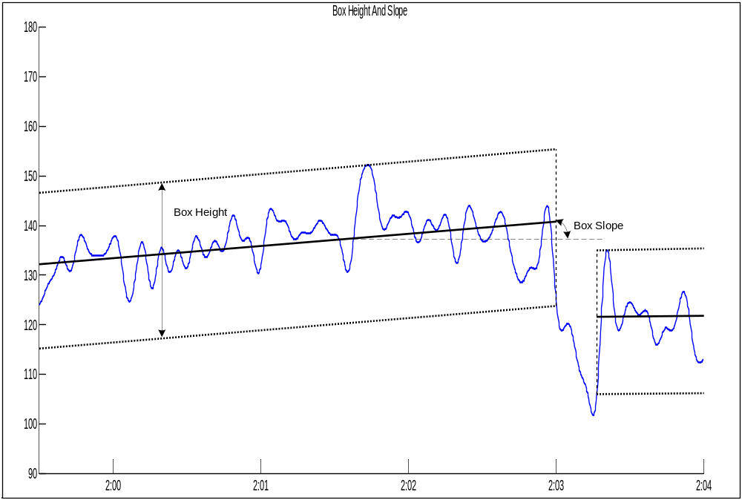
Figure 37: Box Height and Slope

The maximum allowable box height, as a function of ambient variability, is shown in Figure 38, and can be summarized as:

h_{MAX} = { 1.05 * ((27 * VAR_{A}) + 3), VAR_{A} <= 1
31.5, VAR_{A} > 1},

where VAR_{A} is the ambient variability and is taken as the mean of the minVar values at the start, middle and end points of the box in question.
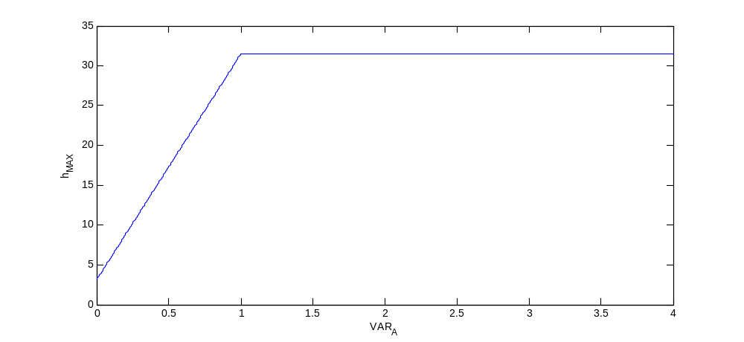
Figure 38: Maximum box height as function of variability
The maximum allowable slope, as a function of box length, is shown in Figure 39 and is summarized as:

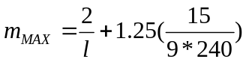,

where l is the box length in samples (assumed to be at 4Hz), and a minimum box length of 20 seconds (80 samples) is assumed.
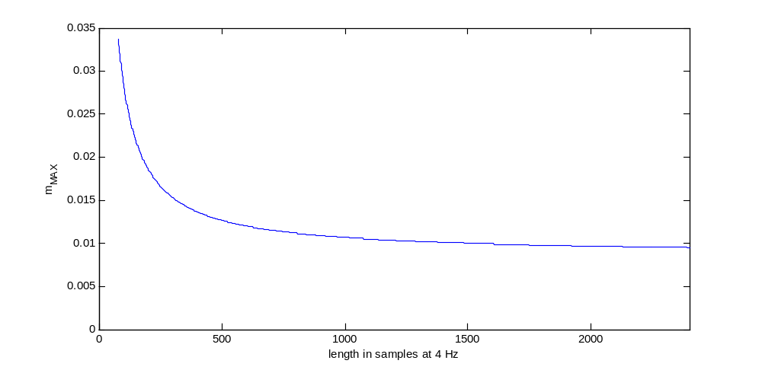
Figure 39: Maximum slope as function of box length

It should be noted that the height requirements have been relaxed as compared to the original baseline algorithm. This is due to the fact that baselines in expert markings were on average much longer than those found during the original implementation of baseline detection. The relaxing of slope and width constraints allowed for a closer match between expert markings and baseline detection output in terms of baseline length distributions.

The high-level flow of the search algorithm for the set of longest boxes is shown in Figure 40, where x1 refers to the start index of a potential box, and x2 to the end index. In the first processing iteration, x1 is inialized to 1.

From a given start index (x1), the CalcExtremaBoxes algorithm stretches a box as far as it can while respecting height and slope criteria (longest_box_right). In some cases, no valid box can be found that meets minimum length criteria (20 seconds). If a valid box is found, this current box is merged with the set of existing boxes that were stretched from prior start points.

The current box may or may not overlap prior boxes. In cases where there is overlap between the current box and a prior box, a merge is attempted. Ideally the boxes can be combined to form one valid box, but in most cases the space spanned by two overlapping boxes is subdivided in a way such that two new valid boxes are created. In some cases, no merge is possible and the current box is discarded.

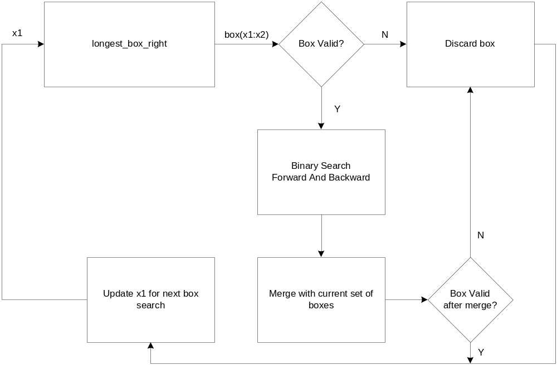
Figure 40: CalcExtremaBoxes high-level flow

After the current box is merged or discarded, x1 is advanced to the sample index of the next search start point, and the search is redone from this new starting point. This process is repeated until there is no more signal to search. These steps are discussed in more detail below.

Longest Box Right
The longest_box_right portion of CalcExtremaBoxes attempts to extend a box from a given starting point to a farthest possible x2, while respecting height and slope criteria. The process is detailed in Figure 41.
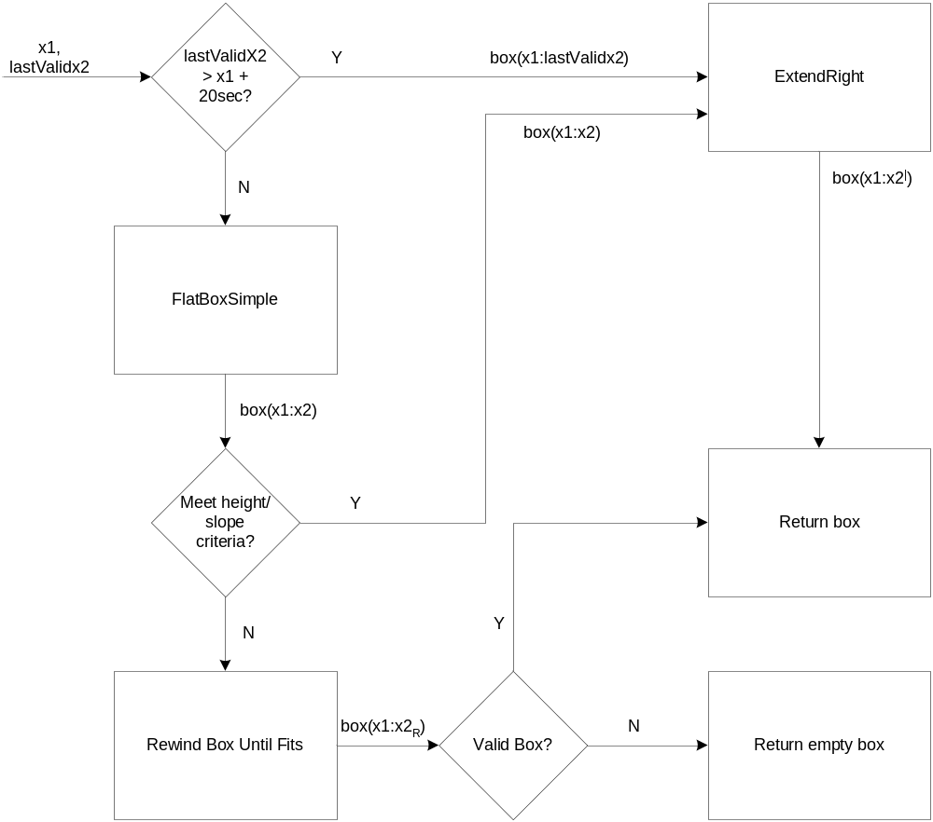
Figure 41: LongestBoxRight

FlatBoxSimple

FlatBoxSimple extends from a point x1 to a farthest possible x2 while respecting the following constraint:

max{x1:x2} - min{x1:x2} is less than h_{MAX},

where h_{MAX} is the maximum box height that is updated as the the box is extended.

FlatBoxSimple searches across the extrema that were earlier identified in order to extend x2 in a more efficient manner. A binary search between the last valid extrema and the first extrema where the height conditions were no longer respected is performed to find a more precise maximum extension.

Essentially, FlatBoxSimple attempts to extend a box while ignoring slope and concentrating solely on height criteria. Because determining a box slope requires a linear interpolation, FlatBoxSimple is a much more efficient way to traverse signal that is most likely considered flat.
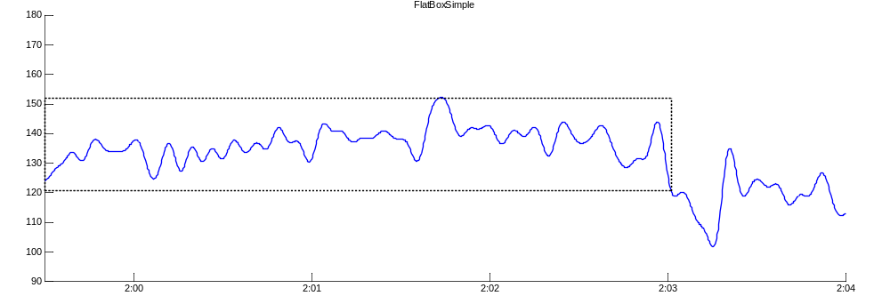
Figure 42: FlatBoxSimple

In cases where there already exists a valid box (from a previous search) that extends more than 20 seconds past the current x1 (i.e. lastValidX2 > x1), the FlatBoxSimple step is skipped. In these cases, the current box has an initial x2 equal to the last valid box end index (lastValidX2) and progresses straight to the ExtendRight step.

RewindUntilFits

Once a box has been extended by FlatBoxSimple, a sloped version of the box is created (with slope based on linear interpolation of signal within the box). In some cases, this box will be invalid, even though the ‘flat’ version of the box met height requirements.

RewindUntilFits ‘rewinds’ the x2 of a box that fails the height or slope criteria. The rewinding proceeds from the current endpoint over extrema and extrema midpoints, until the box satisfies the slope and width criteria or reaches a maximum rewind. Maximum width thresholds are updated dynamically as the endpoint is rewound. The first valid box found in the rewinding process is returned, without proceeding to the ExtendRight step. If the maximum rewind is reached, then an empty box is returned.

ExtendRight

For cases where the sloped version of the box from FlatBoxSimple is still valid (as occurs in most cases), the box is further extended using ExtendRight. ExtendRight is similar to FlatBoxSimple in that it traverses extrema midpoints (as opposed to extrema) until a box fails to meet height criteria, except in this case the box can be ‘sloped’ where the slope is determined by the linear interpolation of the signal within the current box. The box height is then measured in relation to this linear interpolation. In addition to respecting height thresholds, maximum slope criteria must also be respected by the advancing box. As in FlatBoxSimple, the maximum box height is updated as the box is extended, based on the ambient variability.

Figure 43 shows an example of a FlatBoxSimple result (dotted black line) followed by further extension of the box in the ExtendRight step (dotted red line).

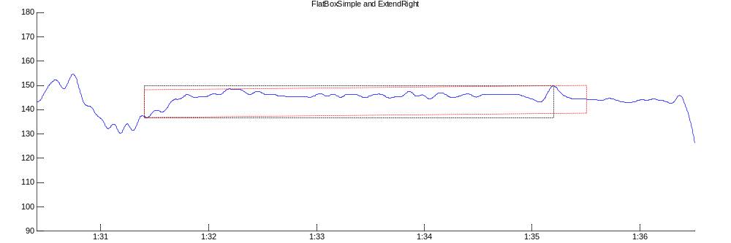
Figure 43: FlaxBoxSimple (black) and ExtendRight (red)

Binary Search Forward/Backward
Given a valid box returned from LongestBoxRight, we attempt to do a backwards extension (extend x1 back in time) by performing a binary search between the end of the last valid box and the start of the current box. In cases where the current box overlaps the last valid box, no backwards extension is attempted. It should be noted that a binary search is not actually an appropriate search method, as the search is unordered (failure at x1 does not preclude success at x1-1 and vice versa). As a proper backwards search would require a sample-by-sample advancement, a binary search is used although not entirely suitable for the search problem. As successful backwards extension is quite rare, this was deemed to be a reasonable compromise.

A forward binary search is also done on all valid boxes return from LongestBoxRight. The search is done between the current x2 and the extrema at which the box was first not valid (as deduced in ExtendRight). While this search is also not ordered, it is very close to being ordered (because it uses extrema but they do not take into account the slope of the box) and a binary search was deemed adequate. Both the backwards and forwards binary searches can be seen as a fine-tuning of the box limits.

Merging boxes
If a box is found that meets the required criteria, is longer than the minimum baseline length (20 seconds) and ends after the end point of the last valid box that was found, it can be added to the set of boxes that were already found. In most cases, however, a box will have overlap with a previous box. These boxes must be merged or truncated such that the final baselines will not have any overlap, while still meeting the required baseline criteria. A sample merge is shown in Figure 44, between a new box (shown at top in red) and an existing box (shown at top in black). The space spanned by these two boxes is subdivided in such a way to provide two valid non-overlapping boxes (shown at bottom).
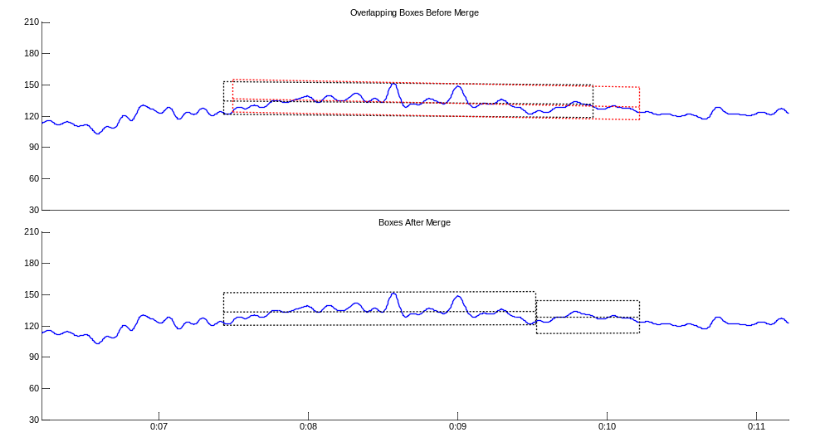
Figure 44: Merge of overlapping boxes

The merge process goes through the following steps, until two (or one) valid non-overlapping boxes can be found that span the same space as the two overlapping boxes:

- Attempt to merge two overlapping boxes to give one valid box
- Attempt to truncate the shorter of two overlapping boxes to give two valid boxes
- Attempt to truncate the longer of two overlapping boxes to give two valid boxes
- Attempt to find a split point in overlapping space to give two valid boxes
- Discard newer box if shorter than previous box, or do invalid merge (see note below)

When no valid split point can be found to give two valid boxes, and the prior box is shorter than the current box, an invalid merge may be performed. In these cases, a box that does not meet the slope or width criteria can be accepted. If the non-overlapping part of the prior box is less than 20 seconds, then it is simply appended to the current box even though this box does not meet criteria. Otherwise, the non-overlapping part of the last box is kept as a baseline, even though it does not meet criteria. The reasoning behind this approach is to ensure that portions of tracing that were once marked as baseline (at least internal to the algorithm) do not become unmarked, thus ensuring maximum coverage by baseline candidates.

The merging process is shown in the flowchart of Figure 45.
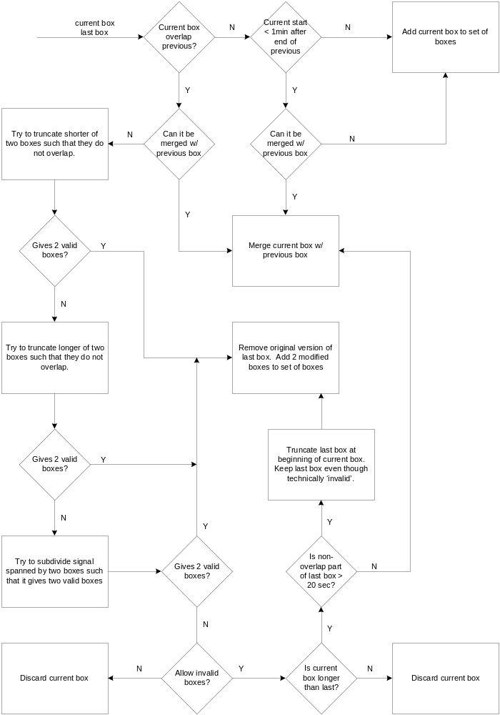
Figure 45: Merging boxes

Advancement of starting position of box (x1)
Longest box searches start from subsequent extrema midpoints. To reduce redundant searching, the search from a given starting position starts from the x2 of the last box search (assuming that this x2 is greater than the current starting position). If the longest box search starting from extrema midpoint n (call this x1_{n}) gives an endpoint x2_{n}, then the search starting from extrema midpoint n+1 (x1_{n+1}) will start with an x2_{n+1} equal to x2_{n}.

Conversion From Boxes to Baselines
Once a set of non-overlapping boxes has been found, they are converted to baseline candidates simply by taking the linear interpolation of the signal contained within the box. A baseline can be defined by its start and end indices (x1 and x2) and the value of the linear interpolation at its start and end indices (y1 and y2).

Computation of Linear Interpolation
One of the main computation expenses of the baseline detection algorithm is the computation of linear interpolations of the signal. Closed form expressions exist for the linear interpolation calculation. These closed forms can be computed if the summations of the signal, and the signal multiplied by the signal index, are available.

The slope m, and y-intercept b, of the linear interpolation of a signal y(x) can be expressed as:

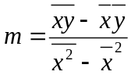 and 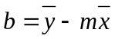
The mean values and cross-correlations used above in the closed-form calculation of the linear interpolation of a signal y, on the interval x1 and x2, can be calculated based on summations of y and xy, as follows:

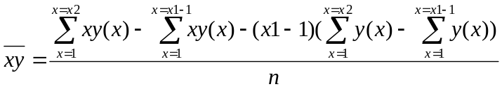,

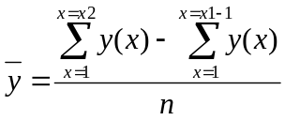,

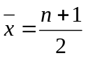,

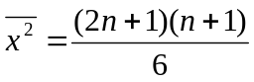,

where n = x2 – x1 + 1

If we have precomputed the summations of y and xy, we can calculate the linear interpolation between any two points on y in constant time. Since we will be doing many linear interpolation calculations, the overhead of precomputing sums is much less than the savings generated by being able to compute linear interpolation in constant time.

Coverage / Processing Time Tradeoffs
The algorithm described above is based on default algorithm parameters. The algorithm can be easily adjusted to tradeoff baseline coverage (percentage of samples that are marked as baseline) and computational complexity. The default configuration is a compromise between the two. Complexity savings can be made by being more aggressive in the advancement of the search starting point and reducing any ‘fine-tuning’ of box boundaries.

Realtime Considerations
The baseline detection module operates on the low-pass version of the FHR, meaning that there is a minimum 81 sample delay on baseline detection output due to low-pass filtering. Baseline detection also uses the minVar signal as a parameter. The last 446 samples of the minVar signal in a window are potentially unstable and subject to change based on future signal. Any baselines that overlap the last 446 samples are thus potentially subject to change based on future signal, and should be considered pending.

Commit Buffer
We define the baseline commit buffer as the samples at the end of a signal window for which a detected baseline candidate may be unstable and subject to change based on future signal. Any baseline overlapping (ending) in the commit buffer is labelled pending. Baselines ending prior to the commit buffer are deemed final. Both pending and final baselines are classified by multiHypothesis and used as reference baselines for accel/decel detection, but only final baselines are used for merging for final output events.

The length of the commit buffer is based on instability due to filtered signals, but also on potential merging of existing candidates based on future signal. In some cases, shorter baseline candidates can be extended if more signal is available. Empirically, it was discovered that a 4-minute commit buffer resulted in stable baseline output (as compared to any larger value for commit buffer). Because pending baselines are still used for accel/decel classification and bump extension, a longer commit buffer does not inject any additional delay into the accel/decel path. Although a 4 minute commit buffer could be considered overly cautious, the band pass filter delays remain the bottleneck in overall output event delay. If band pass filter delays were reduced, then a smaller commit buffer may be appropriate.

If a baseline candidate ends after the start of the commit buffer but starts 5 minutes or more prior to the commit buffer, it can be truncated at the commit buffer boundary so that a portion of the baseline can be labelled as a final baseline, while the remaining portion is pending. This splitting up of longer baselines reduces delay on output events. Figure 46 shows baseline detection output for 4 consecutive windows – final baseline candidates are shown in black and pending baseline candidates are shown in red, while the start of the commit buffer is shown as a black dotted vertical line (the red dotted vertical line will be described below). In the second window (from the top), we can see that the baseline candidate immediately prior to the commit is truncated at the commit buffer boundary.

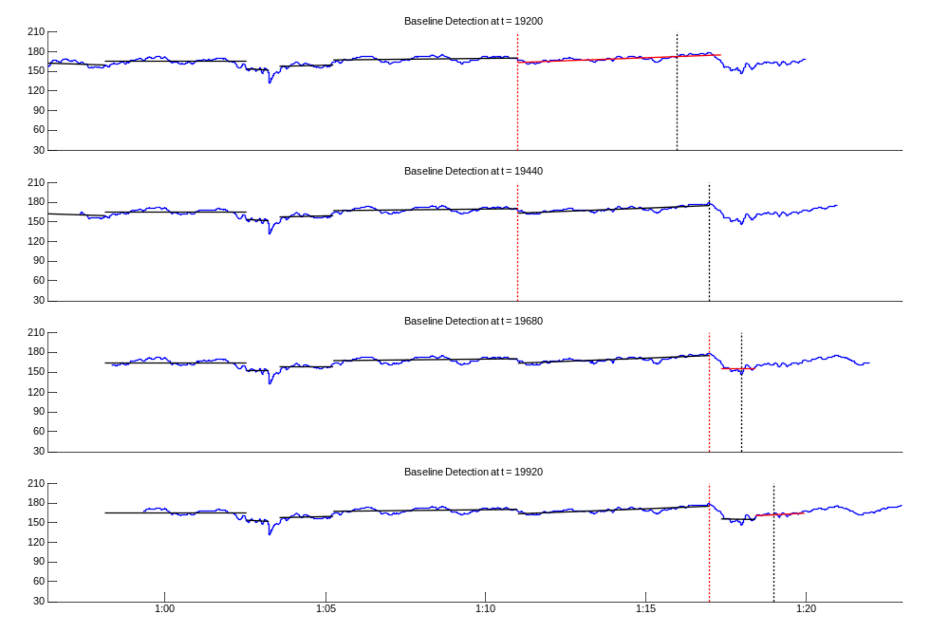
Figure 46: Baseline Detection output for 4 consecutive windows

Inter-window Communication
The baseline detection module has certain markers that allow for a reduction in the signal that needs to be searched for baselines in ensuing windows, based on results from a prior window.

The high-level flow of the baseline detection algorithm is reprinted in Figure 47. The initial x1 value for a given signal window is set to the end index of the last final (as opposed to pending) baseline candidate from the previous window. Pending baseline candidates from the previous window are used as the initial set of ‘current’ boxes in the current window, to which new boxes will be merged. The end index of the last pending baseline candidate for the previous window is used as the lastValidX2 marker, used as input to longest_box_right. In this way, the baseline detection algorithm essentially starts from the end of the last pending baseline, thus reducing redundant searching.

The start point of the baseline algorithm (i.e. the initial x1 value in Figure 47) for each window in Figure 46 is shown as a red dotted vertical line.
Figure 47: Baseline detection high-level flow

In cases where there was no final baseline found in previous windows that is within 5 minutes of the start of the commit buffer, the baseline detection search algorithm will start 5 minutes before the start of the commit buffer (this will happen rarely).

Dealing with Repaired Segments
Avoiding marking substantial periods of repair as baseline ensures that an artificial reference level will not be used for accel/decel classification and for multiHypothesis classification of other baselines.

In order to avoid marking repaired segments of tracing as baseline, we subdivide the signal window into portions of clean signal and apply the core baseline detection algorithm to each window in turn. Figure 48 shows the subdivision of a window into 3 subwindows separated by repair segments (shown in red) greater than 10 seconds in length. The commit buffer is computed as before, based on the overall window (such that the baselines detected in the first two subwindows will be labelled as final. Short periods of repair (less than 10 seconds) need not be skipped over, so as to prevent excessive subdivision of baselines when there are short, intermittent dropouts.

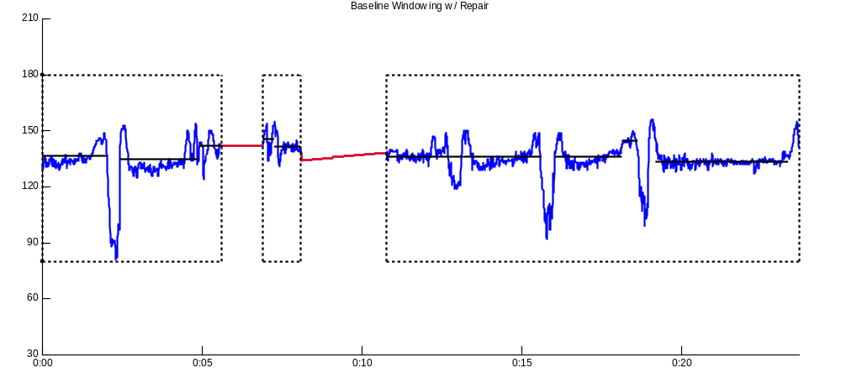
Figure 48: Subwindowing of Baseline Detection in the presence of repair

MultiHypothesis
The MultiHypothesis stage refines the set of baseline candidates found in the baseline detection stage, removing any candidates that are deemed to be not real baseline (such as flat areas at bottoms of decels). The goal is to provide an accurate set of reference baselines that will be used to classify accels and decels, and aid in the accurate determination of accel and decel boundaries (during bump extension).

The classification of a baseline candidate is done using a set of neural networks. Input features for this classification are taken from the baseline candidate in question, as well as the 4 surrounding baseline candidates. There are two separate sets of neural networks used for two types of classification: a primary classification and a secondary classification.

A primary classification derives neural network input features from the 2 baseline candidates immediately preceding and the two baseline candidates immediately following the candidate to be classified. A secondary classification derives neural network features from the 4 baseline candidates preceding the candidate to be classified. The primary classification is in general more accurate, but can only be done after waiting for the next two baseline candidates. The secondary classification can be done immediately, as it depends only on prior events.

Primary Neural Network
For primary classification, features are taken from the baseline candidate to be classified (shown in bold black in Figure 49) and the two baseline candidates immediately prior and immediately following the baseline candidates to be classified (shown in red). Primary classification requires that one wait for two additional baseline candidates to arrive, meaning additional delay before a classification decision can be made.

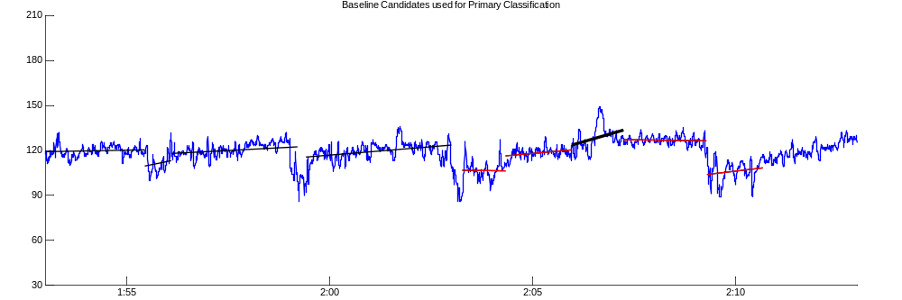
Figure 49: Baseline Candidates for primary classification

In all, there are 55 input features used in neural network classification. They are listed below, with b₂ referring to the baseline candidate to be classified, b₀ and b₁ referring to the two prior baseline candidates, and b₃ and b₄ referring to the two ensuing baseline candidates. The values of the linear interpolation at the beginning and end of a baseline are referred to as y₁ and y₂.

- The length of each of the 5 baselines (5)
- The value of the Variability signal at each baseline midpoint (5)
- The mean FHR value of each baseline (5)
- The variance of the FHR during each baseline (5)
- The value of y₁ for b₁, b₂, b₃, and b₄ (4)
- The value of y₂ for b₀, b₁, b₂, and b₃ (4)
- The length of the gap between each of the baselines (4)
- The value of the Variability signal at the midpoint of each gap between baselines (4)
- The mean FHR value in the gap between each baseline (4)
- The difference between the y₁ value of each baseline and the y₂ value of the previous baseline(4)
- The max FHR value in b₁, b₂, and b₃ (3)
- The min FHR value in b₁, b₂, and b₃ (3)
- The max FHR value in the gaps between b₁ and b₂ and b₂ and b₃ (2)
- The min FHR value in the gaps between b₁ and b₂ and b₂ and b₃ (2)
- The value of the 3-minute moving average of FHR at the midpoint of b₂ (1)

The 3-minute moving average of the FHR at time x is calculated by taking the average of 3 minutes of FHR samples centered at x (i.e. 1.5 minutes prior and 1.5 minutes ensuing).

Secondary Neural Network
For secondary classification, features are taken from the baseline candidate to be classified (shown in bold black in Figure 50) and the four baseline candidates immediately prior to the baseline candidates to be classified (shown in red). Because secondary classification uses only past events, there is no additional delay. Secondary classifications are generally less accurate than primary classifications.

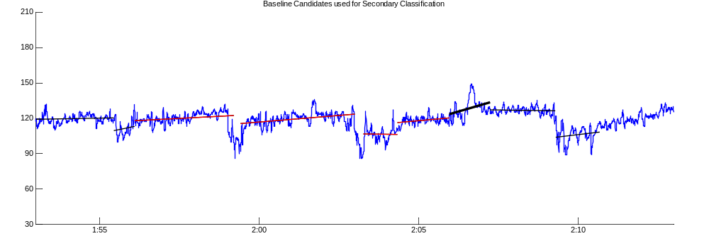
Figure 50: Baseline Candidates for secondary classification
Like in primary classification, there are 55 input features used in Secondary Neural Network classification. Nearly all the features are the same as in Primary classification. They are listed below, with b₄ referring to the baseline candidate to be classified, and b₀ ,b_{1,}b₂, and b₃ referring to the four prior baseline candidates.

- The length of each of the 5 baselines (5)
- The value of the Variability signal at each baseline midpoint (5)
- The mean FHR value of each baseline (5)
- The variance of the FHR during each baseline (5)
- The value of y₁ for b₁, b₂, b₃, and b₄ (4)
- The value of y₂ for b₀, b₁, b₂, and b₃ (4)
- The length of the gap between each of the baselines (4)
- The value of the Variability signal at the midpoint of each gap between baselines (4)
- The mean FHR value in the gap between each baseline (4)
- The difference between the y₁ value of each baseline and the y₂ value of the previous baseline(4)
- The max FHR value in b₂, b₃, and b₄ (3)
- The min FHR value in b₂, b₃, and b₄ (3)
- The max FHR value in the gaps between b₂ and b₃ and b₃ and b₄ (2)
- The min FHR value in the gaps between b₂ and b₃ and b₃ and b₄ (2)
- The value of the 3-minute moving average of FHR at the midpoint of b₄ (1)

Experts And Arbiters

Both the Primary and Secondary Neural Networks are actually a set of 3 neural networks (experts) whose output is combined by another neural network (arbiter), as shown in Figure 51. Each of the experts is trained to identify a certain independent cluster of baseline events. This is done by partitioning the input feature vector space during training. For more details on this cluster-based classification, please refer to doc\autoMarking\Marking\MultiHypothesis\nn\training\NN_cluster_method.doc.

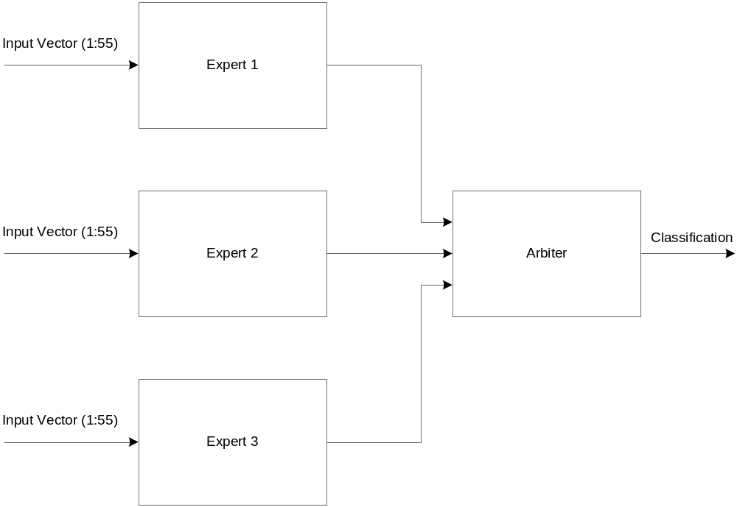
Figure 51: Experts and Arbiter

Realtime Considerations
Multihypothesis classification is done for both pending and final baseline candidates. This is done in order to provide the most information about baselines as possible for the purposes of accel/decel classification. Even if a baseline candidate is pending (and thus potentially subject to change), it can still provide a useful reference baseline level.

Stability of classification
The secondary multihypothesis classification uses the 4 previous baseline candidates to classify the current candidate. A secondary classification is thus stable (in that it will not change based on future information) when a baseline candidate is labelled as final by the baseline detection algorithm, and need not be redone in future windows.

The primary multihypothesis classification uses the 2 previous and 2 ensuing baseline candidates for classification of the current candidate. A primary classification is thus only stable when both of the ensuing baselines are labelled final.

Numbered baseline candidates in a given window are shown in Figure 52, with pending candidates shown in red. All baseline candidates can have a stable secondary classification, while only candidates numbered 1-4 will have a stable primary classification.

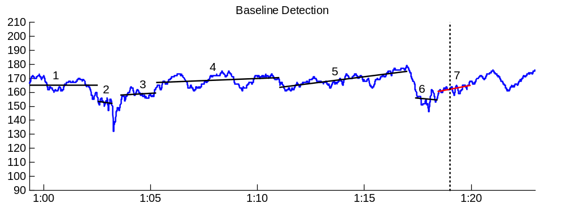
Figure 52: Multihypothesis in realtime

The candidate labelled 5 can be classified using the primary neural network, but the result will be not be stable because baseline candidate 7 is pending and may change based on future signal. Baseline 6 cannot yet be classified using the primary neural network because there is only one ensuing baseline available.

In cases where a classification is temporary (as is the case with baseline candidate 5 in Figure 52), the classification will be redone in ensuing windows, until the classification becomes stable. Once a classification is stable is does not need to be redone in future windows.

Calculation of Features
Features used to classify by the multihypothesis neural networks, such as the minimum, maximum and mean FHR values in a baseline, should only be computed once and then stored. In some cases, baselines used for classification may occur prior to the available signal (i.e. if there are less than 5 baselines in the current window). In addition to reducing redundant computation, storing baseline features allow these baselines to be used for multihypothesis classification even if they have negative relative sample indexes (i.e. if they occur outside the current window). The features particular to a given baseline are as follows:

- Variability signal at midpt of baseline
- Mean FHR value in baseline
- Max FHR value in baseline
- Min FHR value in baseline
- Variance of FHR in baseline
- 3-minute moving average of FHR at midpt of baseline
- Variability signal at point halfway between end of baseline and start of next baseline
- Mean FHR value between end of baseline and start of next baseline
- Max FHR value between end of baseline and start of next baseline
- Min FHR value between end of baseline and start of next baseline

Some neural network input features (i.e. the last 3 listed above) also depend on the ensuing baseline candidate. In cases where the ensuing baseline candidate is pending, these features are unstable and must be recomputed in future windows.

Because classification features are only calculated until those features are stable, baseline candidates buffered for use in multihypothesis classification are independent of the window buffering. Baselines that occured prior to the start of the current signal window can still be used for multihypothesis classification, as any signal dependent features have already been calculated in a prior window. Baselines occuring more than 1 hour prior to the current time are purged from the buffer of baseline candidates.

Primary and Secondary Classification
Multihypothesis is done in each window based on the best information available. Ideally, baseline candidates are classified using the primary neural networks, where all baselines candidates are final (as opposed to pending). This scenario represents the stable, unchanging classification of a baseline candidate.

When a baseline candidate is the last or second last baseline candidate in the window, only a secondary classification can be done. The results of this classification are used in the current window, and the classification will be redone in subsequent windows until the stable primary classification is acheived.

A primary classification using one or more pending baseline candidates is preferred over a secondary classification, even if that secondary classification uses final baseline candidates. In cases where one or both of the ensuing baselines used for primary classification are pending, this primary classification is used in the current window, and the primary classification will be redone in subsequent windows until the two ensuing baseline candidates are final.

Because of the different classification scenarios (secondary, primary w/ pending, primary w/ final), it is possible for a same baseline candidate to be classified as baseline in one window and as non-baseline in another.

AccelDecel
Episodes of peaks and valleys in the FHR signal are known as accelerations and decelerations, respectively. Their duration is typically in the range of 15s to several minutes. Distributions for both decelerations (in pink) and accelerations (in black), based on expert markings of 161 FHR tracings, are shown in Figure 53.

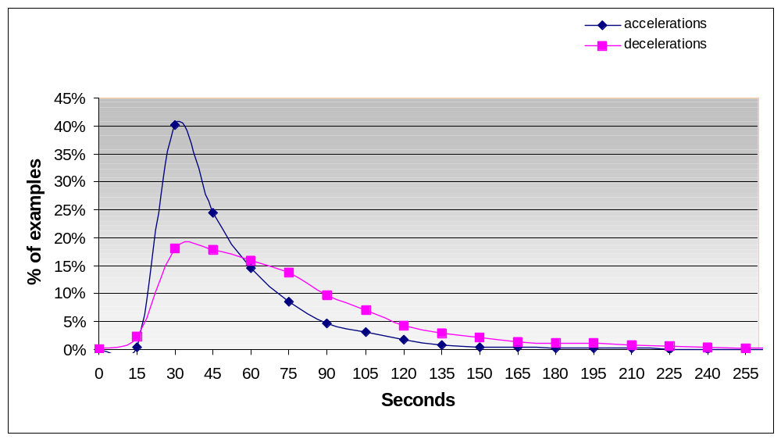
Figure 53: Accel and Decel distributions based on expert markings from 161 tracings

The first step in detecting accels and decels (referred to collectively as bumps)
is to separate the FHR signal into a bank of bandpass signals, targeting different bump frequencies. A set of Candidate Bumps is then derived from these bandpass signals. After some refinement, the decel candidates are classified using a neural network. Decel candidates classified as decels (as opposed to non-decels) are then used to modify the boundaries of accel candidates – portions of overlap between classified decels and accel candidates are considered decels and are truncated from the accel candidates. The accel candidates are then preprocessed for minimum length and height before being classified by a neural network. Figure 54 shows the overall accel/decel detection process.

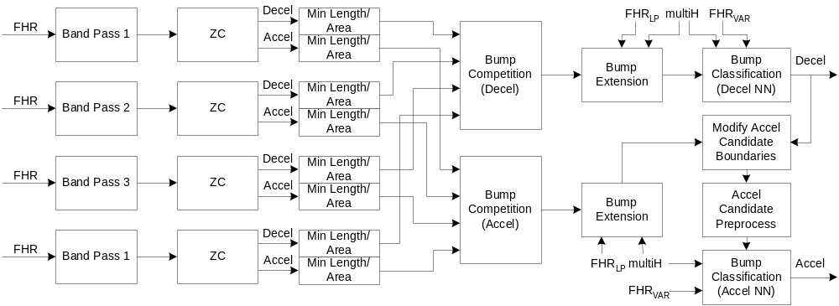
Figure 54: Accel/Decel Detection

Band Pass Filtering
Candidate bumps are detected by subdividing the FHR signal into multiple frequency bands. Identification of signal energy at different frequencies can be thought of as finding potential bumps of different lengths. While the original implementation of Accel/Decel used 6 frequency bands, the realtime version in C++ uses only the lowest 4, to reduce delay introduced by long filters. If operating in an offline environment where delay is not a factor, 6 frequency bands can be used to better detect very long, shallow decels. Filter design specifications for all bands are shown in Table 2. Note that bands 1 and 2 are implemented as cascaded low and high pass filters, and bands 5 and 6 are only suitable for use in offline processing due to their long delays. Frequency responses of band pass filters are shown in Figure 55.

Table 2: Band Pass Filter Design Specifications
Band | Name | Type | Pass Band 1 (Hz) | Pass Band 2 (Hz) | Stop Band 1 (Hz) | Stop Band 2 (Hz) | Pass Band Ripple (dB) | Stop Band Atten. (dB) | Order | Delay at 4HZ (sec)
 | lp25s | LP | 0.04 |  | 0.05 |  | 1 | 70 | 901
 | hp40s | HP | 0.025 |  | 0.0001 |  | 1 | 70 | 392
Band 1 | (total) | LP+HP |  |  |  |  |  |  | 1293 | 161.5
 | lp40s | LP | 0.025 |  | 0.04 |  | 1 | 70 | 601
 | hp60s | HP | 0.0167 |  | 0.0001 |  | 1 | 70 | 588
Band 2 | (total) | LP+HP |  |  |  |  |  |  | 1189 | 148.5
Band 3 | bp3_1081 | BP | 0.0111 | 0.0167 | 0.0001 | 0.025 | 1 | 70 | 1081 | 135
Band 4 | bp4_1839b | BP | 0.005 | 0.0111 | 0.0001 | 0.0167 | 1 | 70 | 1839 | 229.75
Band 5 | bp500_200s | BP | 2 | 4.5 | 0.2 | 7 | 2 | 60 | 3875 | 484.25
Band 6 | bp_660_400s | BP | 0.0015 | 0.0025 | 0.0001 | 0.005 | 5 | 66 | 4558 | 569.75

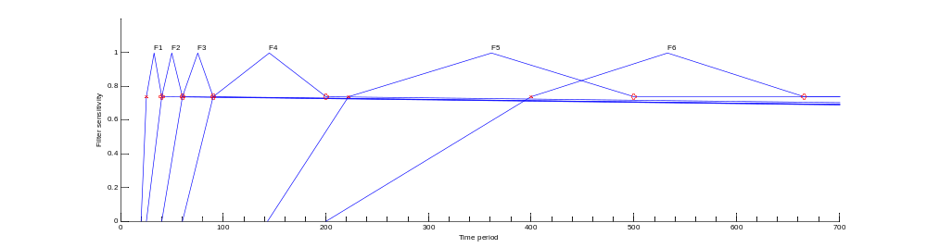
Figure 55: Frequency Response of Band Pass Filters

Zero Crossings
The zero crossings of each band pass signal demarcate the boundaries of the initial set of bump candidates for a given band. Band pass signal segments that are less than zero correspond to decel candidates while segments above zero correspond to accel candidates. As an example, raw FHR and the corresponding band pass signal for Band 3, along with the boundaries of corresponding decel (in red) and accel (in green) candidates are shown in Figure 56.

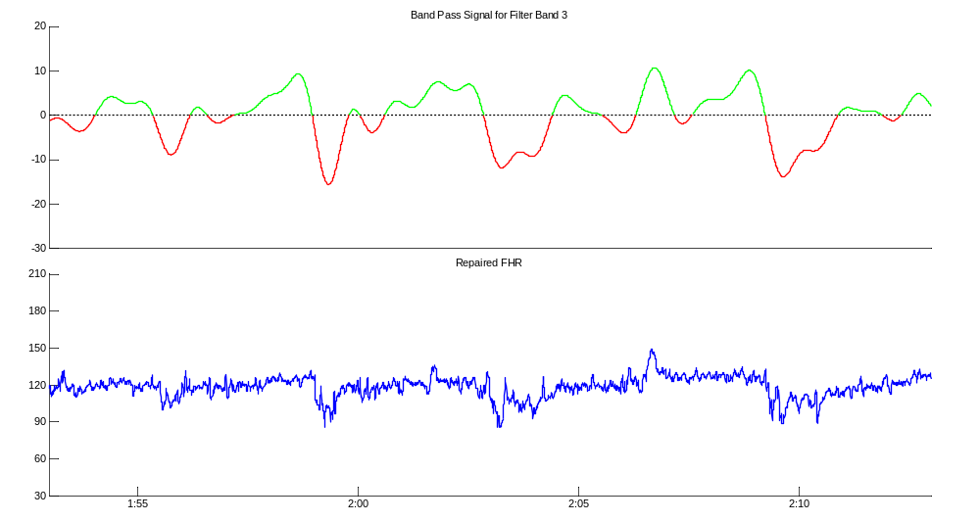
Figure 56: Band Pass Signal for Band 3

Minimum Bump Area and Length
The initial set of accel and decel candidates in each band are first subject to minimum and maximum length thresholds and band-specific minimum area thresholds, where area is calculated in the band-pass domain. This rejects candidates that are obviously not true events. The minimum and maximum length and minimum area thresholds are as follows:
Table 3: Bump Area and Length Thresholds
Band | Min Length (s) | Max Decel Length (s) | Max Accel Length (s) | Min Decel Area | Min Accel Area
1 | 10 | 450 | 255 | 250 | 250
2 | 10 | 450 | 255 | 250 | 375
3 | 10 | 450 | 255 | 300 | 500
4 | 10 | 450 | 255 | 500 | 1000
5 | 10 | 450 | 255 | 2000 | 3800
6 | 10 | 450 | 255 | 2000 | inf

Length thresholds are the same across all bands, although in practice minimum length thresholds will usually only apply to band 1, and maximum length thresholds to bands 5 and 6. Length and area thresholds were determined through analysis of the initial sets of bump candidates as compared to expert markings. Having an explicit upper bound on bump candidate length simplifies timing and delay requirements in a realtime environment. It should be noted that the bump extension stage can extend a candidate bump beyond the maximum length thresholds – the thresholds in Error: Reference source not found only apply to the band pass domain. It should also be noted that when using band 6, accels are not considered.

Bump Competition
The decel bump competition combines decel candidates from different bands into one set of non-overlapping decel candidates. The accel bump competition does the same for accel candidates. The maximum height (deviation from 0) in a bump’s bandpass domain is the criteria used to select between two overlapping accels or decels from different bands.

The set of overall decel candidates is initialized as the set of band 1 candidates that meet length and area requirements. The set of band 2 candidates is then merged with the existing set of band 1 candidates. If candidates overlap, then the candidate with the greatest band pass domain height is kept, while the other is discarded. The set of band 3 candidates is then considered in the same way, merged to the set of merged band 1 and band 2 candidates. This process proceeds until all bands (4 in realtime, 6 offline) have been considered.

A sample bump competition is shown in Figure 57, with bump competition winners shown in bold in the corresponding band pass signal. The output streams of the bump competition are a set of non-overlapping accel candidates and a set of non-overlapping decel candidates.
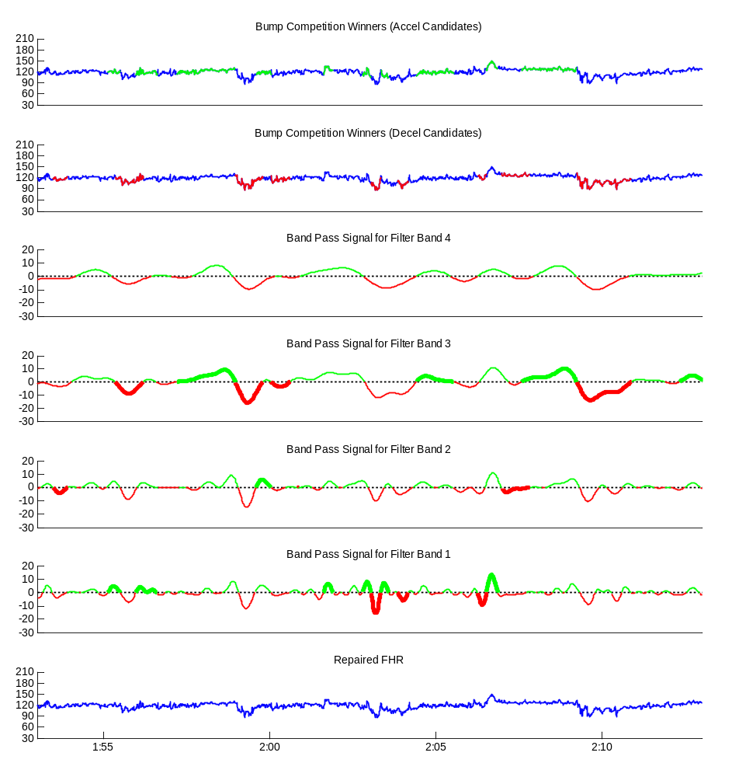
Figure 57: Bump Competition

Bump Extension
The boundaries of candidate bumps are sometimes underestimated, especially for long and/or deep decelerations. The bump extension stage refines the boundaries of decel and accel candidates by using a hill-climbing algorithm on the low-pass version of the FHR.
The bump extension algorithm works by pushing out each of the start and end boundaries of a bump candidate until one of the following stopping conditions is encountered (operating on the low-pass FHR):

- A reference baseline level is reached
- A local maximum is found
- A flat segment is encountered

Other conditions that will halt a bump extension are:
- Encountering a repaired segment
- Reaching a prior committed output event

The local maximum and flatness stopping conditions can be ignored if they occur at an FHR level that is 25 bpm or more less than a reference baseline. This allows the algorithm to properly extend large and/or biphasic decelerations despite encountering a local maximum or flatness.

The extension of a bump start boundary is known as backwards extension and that of the end boundary as forward extension.

Reference Baseline
The reference baseline is taken as the first multiHypothesis baseline of at least 60 seconds in length starting prior to the beginning of the bump candidate to be extended. If the reference baseline overlaps the bump candidate, then it is truncated and the length of the truncated baseline must be at least 60 seconds in order to be used. This 60 second threshold insures that the reference baseline level is robust.

Because the bump extension algorithm operates on the low-pass FHR, the level of the reference baseline must be translated to the low-pass domain. The reference baseline level is thus taken as the mean of the low-pass FHR samples in the reference baseline.

If during the iterative extension procedure the bump extends into the reference baseline, the reference baseline boundaries are recomputed. If this truncation results in a baseline that no longer meets length requirements then a new reference baseline must be found.

Upto Baseline
Bump extension for a given bump boundary is halted if the value of the low-pass FHR at boundary is greater or equal to the reference baseline level.
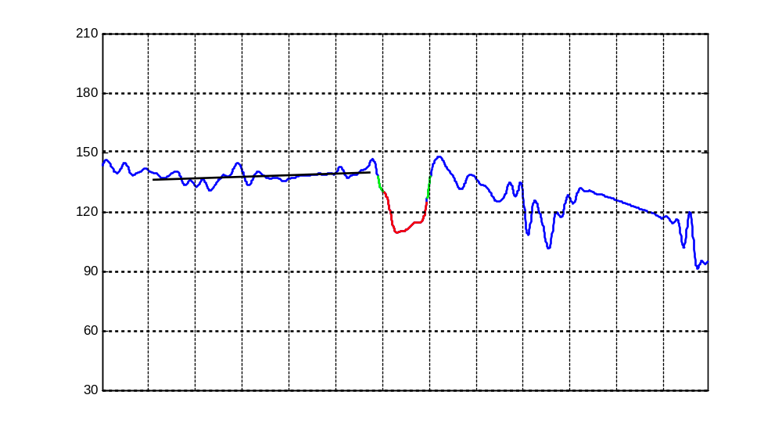
Figure 58: Extension upto Baseline
Figure 58 shows a case where both backward and forward extensions are halted because the reference baseline (shown) level was reached. The red portion of the decel represents the original non-extended boundaries, and the green portions show the bump extension.

If no adequate reference baseline level was found, then the ‘upto baseline’ stopping condition is not considered.

In cases where the low-pass FHR level at the extended starting boundary of the bump candidate is 15 bpm or more lower than the reference baseline level, the level at the extended starting boundary is used as a reference for the purposes of forward extension. This is intended as an additional safeguard against poor reference baselines and possible over-extension of bumps.

Local Maximum
In the context of bump extension, a local maximum is defined as a sample that is greater than any other sample within 5 seconds. Bump extension is halted if a bump boundary is a local maximum, unless the local maximum is at a level 25 bpm or more below the reference baseline level. The local maximum stopping condition is shown for forward extension in Figure 59. A large biphasic deceleration where the local maximum stopping condition is ignored because it is more than 25 bpm below the reference baseline level is shown in Figure 60. Again, the original decel boundaries are shown in red, and the extension is shown in green.
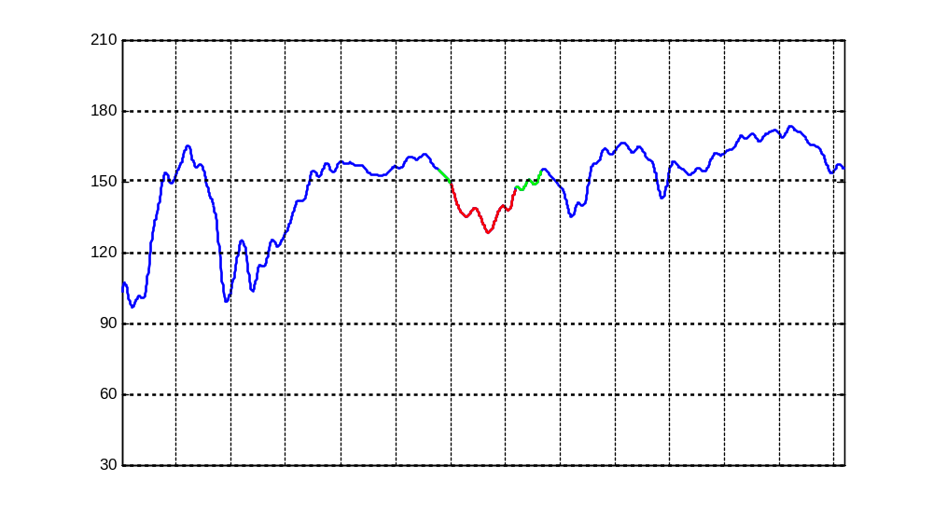
Figure 59: Local Maximum on forward Extension
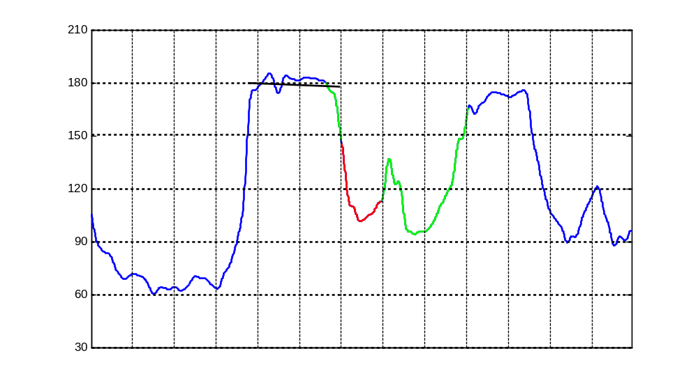
Figure 60: Ignore Local Max on Forward Extension

Flatness
Flatness is defined by two criteria:

- A minimum slope of 0.2 bpm/sec between the current sample and the sample 10 seconds away, in the direction of extension.
- A minimum instantaneous slope (first derivative) of 0.3 over all 10 samples in the direction of extension.

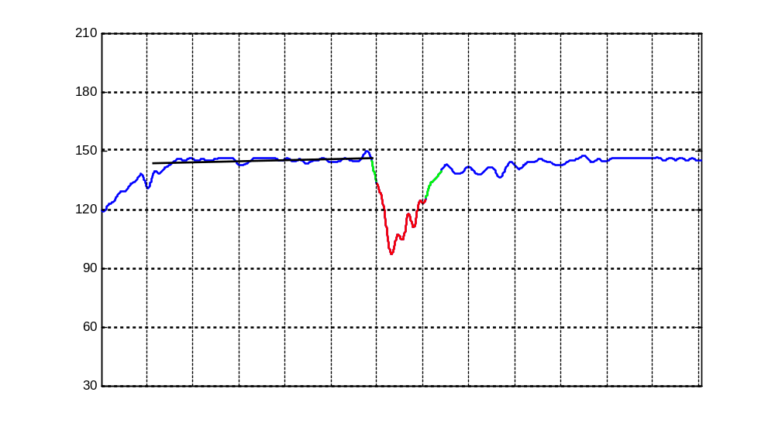
Figure 61: Flatness on forward extension
If both of these flatness conditions are true, then extension is halted in that direction. The first condition serves as a quick check for possible flatness but only considers the difference between two sample values. The second condition ensures a more fine-tuned detection of true flatness, and is only computed if the first condition is true.

Repair
Bumps are not extended into signal that has been repaired. If a repaired segment of at least 10 seconds in lenght is encountered, then extension is halted.
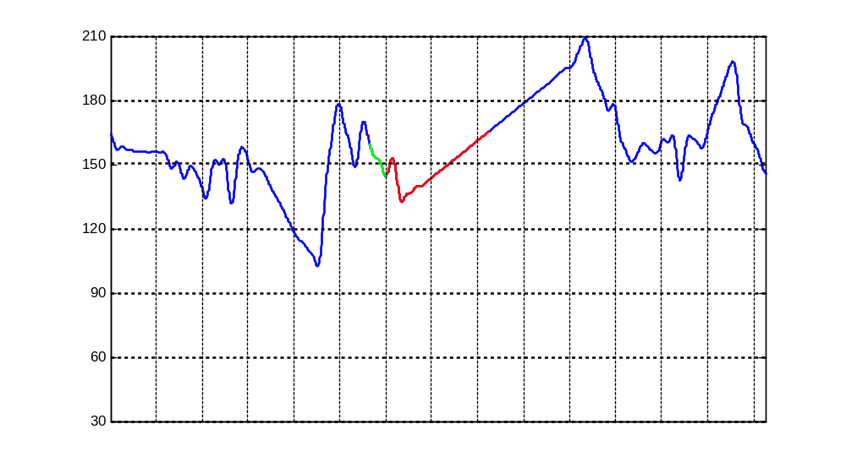
Figure 62: No forward extension due to repair

Overlapping Bump Candidates
While the bump competition ensures that bump candidates of the same type (accel or decel) are not overlapping in time, the bump extension stage does not. Bumps of the same type can be extended into each other – generally when this happens then what were previously two bump candidates become one (as is the case with a large biphasic deceleration – see Figure 60). If two or more overlapping bump candidates of the same type overlap, then in the case where they are both classified as true events, their overlap will be taken care of during the Merging process, guaranteeing non-overlapping final output events.

Bump Classification
Given the set of extended bump candidates, there are still many ‘false’ events to be removed. To accomplish this, more detailed measurements of the event shape and timing characteristics are performed. A neural network is trained to discriminate true and false events in a representative data set using these measurements and expert markings. Given sufficient numbers of event examples during training, this network can be used to classify events not seen in the training event population.

Accel candidates are classified as either an accel or a non-accel, while decel candidates are classified as either a gradual decel, an abrupt (variable) decel or as a non-decel. Separate neural networks exist for the classification of accel candidates and decel candidates. Some features are common to both accel and decel classification, while others are used only for one or the other (the original version of Patterns used common features for both accel and decel classification – these original features are the same as are currently used for decel classification). The common features are as follows:

Length: the time duration of the event
FhrBegin: the FHR values at the beginning of the event FhrEnd: the FHR values at the end of the event FhrStd: the standard deviation of the FHR over the event
FhrPrev: the FHR level in the baseline immediately preceding event
FhrNext: the FHR level in the baseline immediately following event
MaxHeight: the difference between the average of FhrBegin, FhrEnd and the peak FHR
MeanHeight: the difference between the average of FhrBegin, FhrEnd and the mean FHR
Area: the sum of differences between the mean FHR and the FHR at each event sample
VarMax: the maximum variability over the event
VarPrev: the minimum variability in the baseline preceding the event VarNext: the minimum variability in the baseline following the event

Features used only for decel classification are:

Onset: the time from the beginning to 90% of the peak value (in band pass domain)
Recovery: the time from 90% of the peak value to the end (in band pass domain)
FhrInSlopeVal: the steepest slope during event onset (in band pass domain)
FhrInSlopeTime: the time from the beginning to FhrInSlopeVal (in band pass domain)
FhrOutSlopeVal: the steepest slope during event recovery (in band pass domain)
FhrOutSlopeTime: the time from the beginning to FhrOutSlopeVal (in band pass domain)
ContractionBegin: the time elapsed since the onset of the associated contraction
ContractionEnd: the time elapsed since the end of the associated contraction

Features used only for accel classification are:

SlopeTimeIn25: time of maximum slope to peak (measured in lowPass25 domain)
SlopeTimeOut25: time of maximum slope from peak (measured in lowPass25 domain)
Onset25: time to 90% of peak (measured in lowPass25 domain)
Recovery25: time from 90% of peak (after peak) to end (measured in lowPass25 domain)
OnsetSlope25: slope from start to Onset25 (measuresd in lowPass25 domain)
RecoverySlope25: slope from recovery25 to end (measured in lowPass25 domain)
lastDecelX2: # of samples since end of last decel
nextDecelX1: # of samples to start of next decel
decelRate: percentage of last 30 minutes made up of decels

The lowPass25 domain is the signal as filtered by the low pass filter of band 1, (lp25s in Table 2). This signal is used to measure slope features for accels instead of the bandpass signal because the accel candidate boundaries are subject to change when merged with decels. The bandpass features only apply to the bump if its boundaries correspond to zero-crossings of the bandpass signal in question. While the same holds true for decels that are extended, the bandpass features (FhrInSlopeVal etc...) were shown to perform better in classification than the lowPass25 features for decel classification.

For features using the previous or next baseline (FhrPrev, FhrNext, VarPrev, VarNext), a previous baseline is truncated at the start of the bump candidate, in cases where they overlap. Similarly, a next baseline is truncated at the end of the bump candidate, in cases where they overlap. In cases where no next baseline is available (which can happen in a realtime scenario when waiting is considered too costly), the values for FhrPrev and VarPrev are used for FhrNext and VarNext.

Accel Candidate Preprocessing
Decel candidates are classified prior to accel candidates, and then used to modify the boundaries of accel candidates. Decel candidates classified as decels (as opposed to non-decels) are merged with the set of accel candidates, truncating any accel candidates that overlap. The resultant accel candidates are then filtered based on height and length, where a minimum height of 15 bpm and a minimum length of 15 seconds is required to advance to NN classification.

Associated Contractions
In general, a contraction is deemed associated with a decel if the two events have a period of overlap, and generally it is preferable that the contraction leads the decel as opposed to the other way around (decelerations can be thought of as a response to contractions).

Contractions are assigned as associated to a decel in the following order of preference:
- The contraction starts before the decel candidates and ends after the start of the decel candidate
- The contraction ends 20 seconds or less before the start of the decel candidate
- The contraction ends after the start of the decel candidate and starts no more than 20 seconds after the start of the decel candidate

Condition 2) is only considered if there are no contractions that fulfill condition 1), and similarily condition 3) is only considered if no contractions fulfill either of conditions 1 or 2. If no contraction exists that fulfill any of the criteria, then the bump has no associated contraction. In these cases, a outlying value of 240 (meaning contraction occured 1 minute after decel) is used for contractionBegin and contractionEnd for the purposes of NN classification.
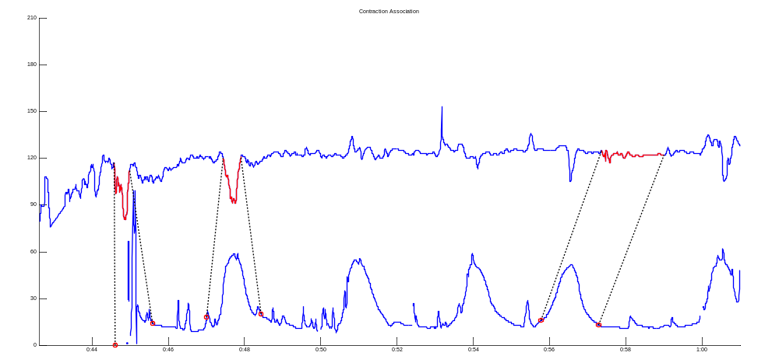
Figure 63: Contraction Association (Case 3, 1, and 2 respectively)

Subtyping of Decels
Decelerations classified as gradual by the neural network are subclassified into one of four subtypes, based on the timing relationship with their associated contraction. The four possible subtypes for gradual decelerations are:

- Early
- Late
- Indeterminate
- Unassociated

In order to subclassify a gradual deceleration, the beginning, peak and end times of both the deceleration and its corresponding contraction are required. The deceleration peak time is defined as the time of the minimum fhr value during the deceleration.

Timing relationships for early and late decelerations are shown below in Figure 64 and Figure 65. Early decelerations occur more or less in phase with a contraction, while late decelerations lag their associated contraction in time. They are subject to the following timing constraints:

For both early and late decelerations, the deceleration must start no more than 10 seconds before the beginning of the associated contraction. Otherwise, the deceleration is deemed to not have been a response to that contraction and is classified as either indeterminate or unassociated.

A deceleration peak is considered to be in phase with a contraction peak if it occurs no more than 10 seconds after that contraction peak. For a deceleration with a peak that is in phase, the deceleration must end no more than 20 seconds after the end of the contraction in order to be considered early. Otherwise it is considered late.

For a deceleration with a peak that is not in phase, the deceleration must end at or before the same time as the end of the contraction in order to be considered early. Otherwise it is considered late.

Indeterminate decelerations are defined as decelerations that do not qualify as early or late but have some overlap with the associated contraction. Unassociated decelerations either have no associated contraction or no overlap in time with a contraction deemed associated.
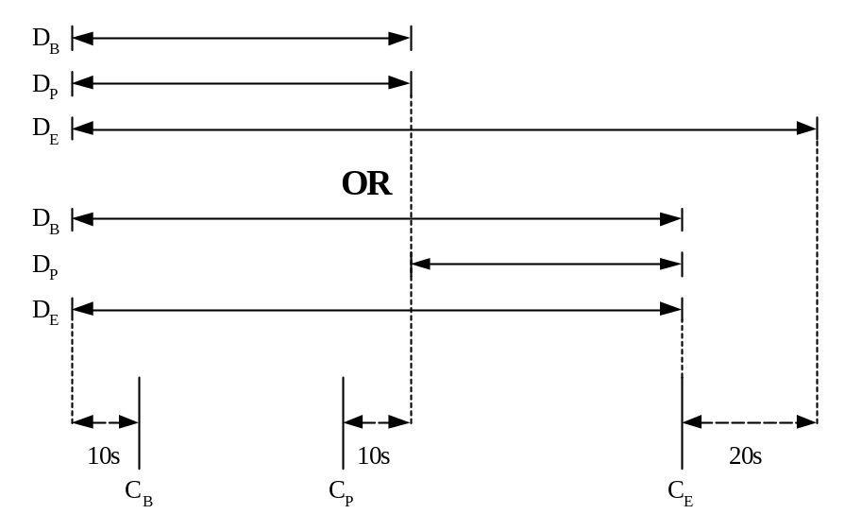
Figure 64: Timing for Early Decel

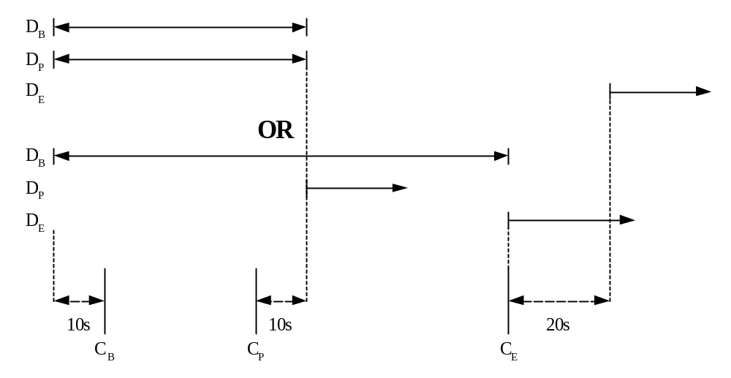
Figure 65: Timing for Late Decel
In the above figures, D_{B}, D_{P}, D_{E} refer to the deceleration begin, peak and end times, respectively, while C_{B}, C_{P}, C_{E} represent the begin, peak and end times of the associated contraction. It is assumed that D_{B} < D_{P} < D_{E} and that C_{B} < C_{P} < C_{E}. Double-arrowed lines represent a finite range, while single-arrowed lines represent a range with no bound on the arrowed end.

Decelerations classified as abrupt by the NN are not subtyped.

Realtime considerations
Accel/Decel classification and merging of output events become more complicated in a realtime environment, as stability of output events needs to be assured while still minimizing output delay on those events.

Band Pass Filtering
Like the low-pass and variability filters, band-pass filtering is done for the entirety of the window at each processing iteration – there is no memory from one window to the next. Band pass filtered signals for a given window are shown in Figure 66. Note that for each band pass signal, the first f_{d} samples of the filtered signal are invalid due to filter end effects, and there is no filtered signal for the last f_{d} samples, where f_{d} is the delay of the band pass filter in question. Portions of signal shown in red are invalid due to filter end effects.

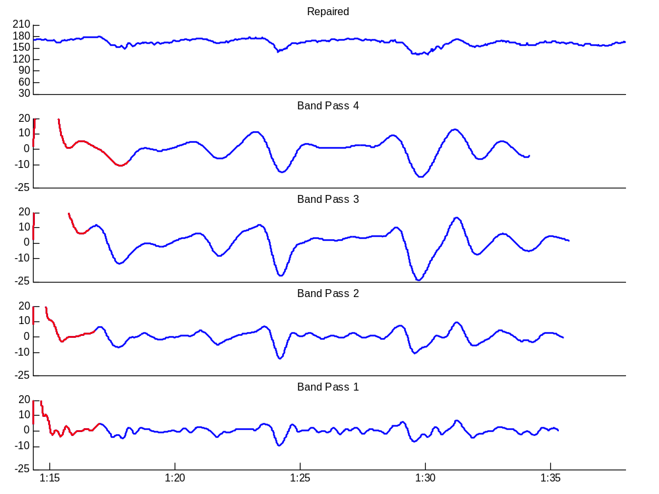
Figure 66: Band Pass Signals in Window

Bump Competition

The commit index is defined as the largest sample index at which the bump competition remains stable. There exist different commit indexes for accel and decel candidates, denoted respectively as CI_{Acc} and CI_{Dec}. A bump competition winner is deemed stable if it ends before the associated (accel or decel) commit index. In these cases, future signal cannot result in a bump competition winner becoming a non-winner. Any stable bump competition winner can proceed for extension and classification.

A per-band decel commit index is calculated as follows:
a) the last sample of band-pass signal, if the last signal sample is greater than zero
OR
b) the last zero crossing, if the end of the signal is less than zero

The overall decel commit index is then taken as the minimum of the per-band decel commit indexes.

A per-band accel commit index is calculated as follows:
a) the last sample of band-pass signal, if the last signal sample is less than zero
OR
b) the last zero crossing, if the end of the signal is greater than zero

The overall accel commit index is then taken as the minimum of the per-band accel commit indexes.

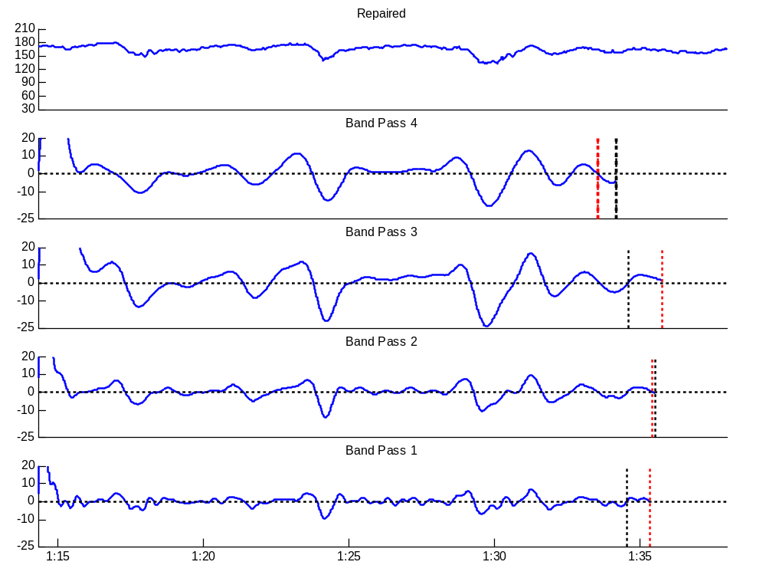
Figure 67: Per-band and Overall Commit Indexes

The per-band decel (as red vertical line) and accel (as black vertical line) commit indexes, as well as the overall decel and accel commit indexes (shown in bold) for a given window are shown in Figure 67. In many cases, the per-band commit indexes in band 4 will determine the overall commit index, as the band 4 filter delay is greatest.

In general, the accel and decel commit indexes will occur at least BP_{MAX} prior to the end of the available signal, where BP_{MAX} is equal to the longest band pass filter delay. The furthest back in time that the decel commit index can be is BP_{MAX} + DCL_{MAX} – 1 samples, where DCL_{MAX} is the longest possible pre-extension bump candidate length. The earliest start index for a decel candidate that ends after the commit index (i.e. the earliest start point of an unstable decel candidate) is DCL_{MAX} – 1 samples prior to the commit index. If we consider the earliest possible commit index, the earliest possible start point of an unstable candidate is thus 2 * (DCL_{MAX} – 1) + BP_{MAX} samples. This maximum delay on bump competition stability is what dictates the required signal history (of 2 * (DCL_{MAX} + BP_{MAX})) and thus the window size.

Zero Crossings
Zero Crossings are not explicitly saved from window to window, but they are only calculated from the earliest possible start point of a bump candidate not yet considered for classification in a prior window. This earliest possible start point is calculated as:

min{CI_{Dec} - DCL_{MAX}, CI_{Acc} - ACL_{MAX}},

where CI_{Dec} and CI_{Acc} are the overall decel and accel commit indexes calculated in the previous window, and DCL_{MAX} and ACL_{MAX} are the longest possible decel and accel candidate lengths (pre-extension) defined as 7.5 and 4.25 minutes, respectively.

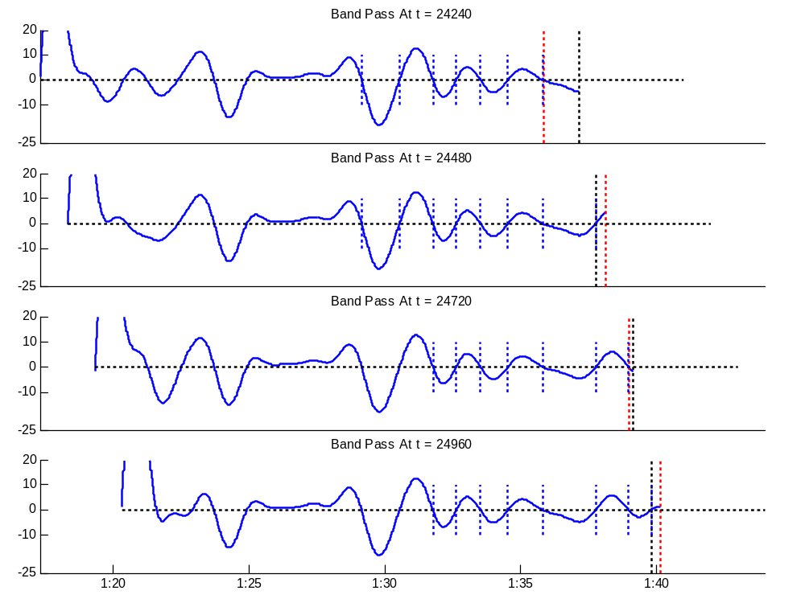
Figure 68: Zero Crossing considered in consecutive windows for band 4

Figure 68 shows zero crossings (as dotted vertical blue lines) considered for 4 consecutive windows for the band pass 4 signal. It should be noted that if we saved zero crossings from window to window (which is not currently done), we could make this more efficient by only looking for zero crossings starting from the last zero crossing ending prior to the minimum of the overall accel and decel commit indexes.

The set of zero crossings is used to generate per-band (pre-competition) bump candidates, which are filtered based on length and area thresholds, as in the offline case (see Table 3). The bump competition then proceeds as in the offline case, except that the winners are initialized to the set of bump competition winners from previous windows. This ensures that the set of bump competition winners will be consistent regardless of block size. Even though these previous bump competition winners will have already been extended and classified in a prior window, they may still affect the bump competition outcome of bump candidates that are not yet stable.

The bump competition flow is shown in Figure 69. Once a set of bump competition winners is determined, those winners that had already been considered in prior windows are removed from the set of winners specific to the current window (they will remain stored in a buffer of winners spanning all windows). These ‘old winners’ can be identified by an end index prior to the relevant (accel or decel) commit index from the previous window.

Any bump competition winners that end after the relevant commit index from the current window are also discarded as these are not yet stable and future signal may affect their status as winners. The remaining bump competition winners are those that are newly stable in the current window and will proceed for bump extension and classification. The newly stable bump competition winners are also added to a buffer of all bump competition winners. This buffer is used as the seed for the bump competition in subsequent windows.

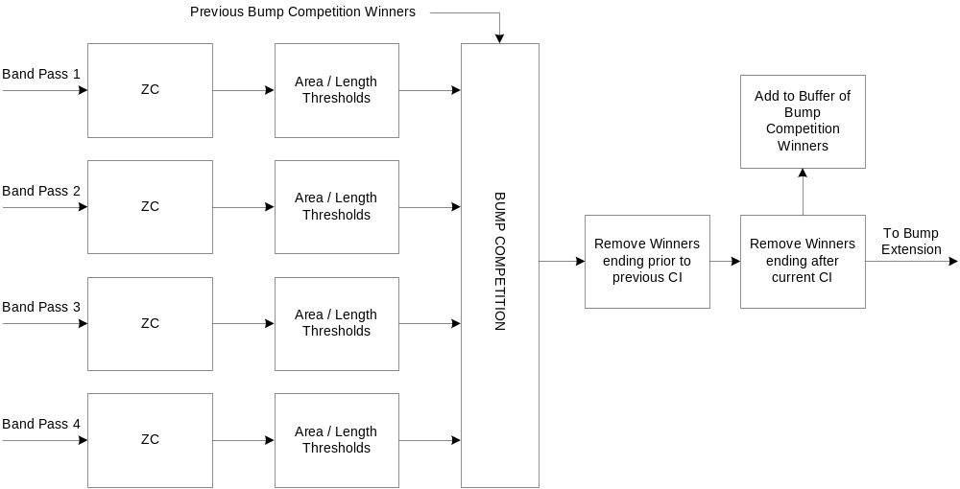
Figure 69: Bump Competition

The process described above and shown in Figure 69 ensures a stable bump competition output while also ensuring that the same bump is not extended or classified more than once over multiple windows. Figure 70 to Figure 73 shows the bump competition across all 4 bands for 4 consecutive windows (using a block size of 240 samples). Zero crossings considered are shown as blue horizontal dotted lines, per-band (pre-competition) bump candidates are shown in dotted (faint) green and red, bump competition winners are shown in solid green and red, while the filtered set of bump competition winners for each window (denoting winners that are newly stable in the current window) are shown in thick green and red.
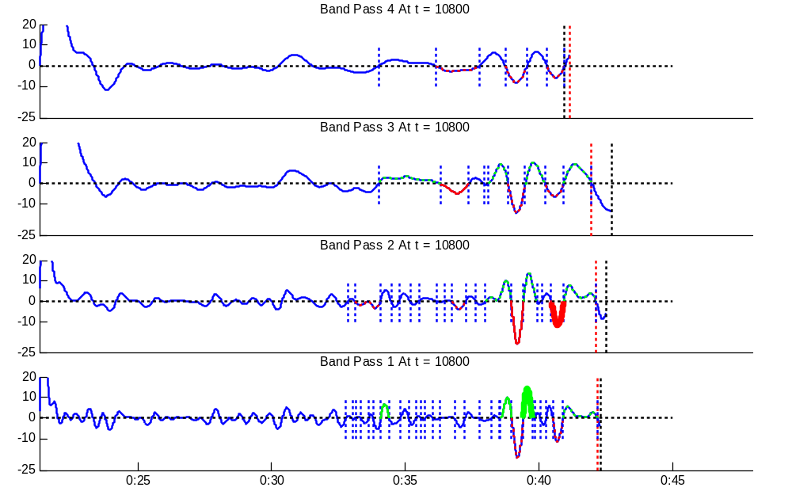
Figure 70: Bump Competition at t = 10800 samples
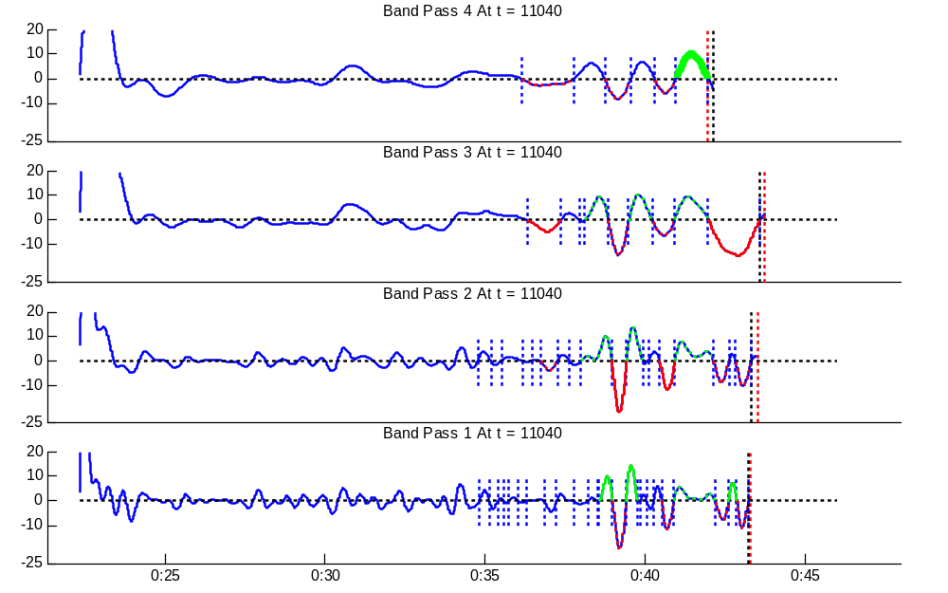
Figure 71: Bump Competition at t = 11040 samples
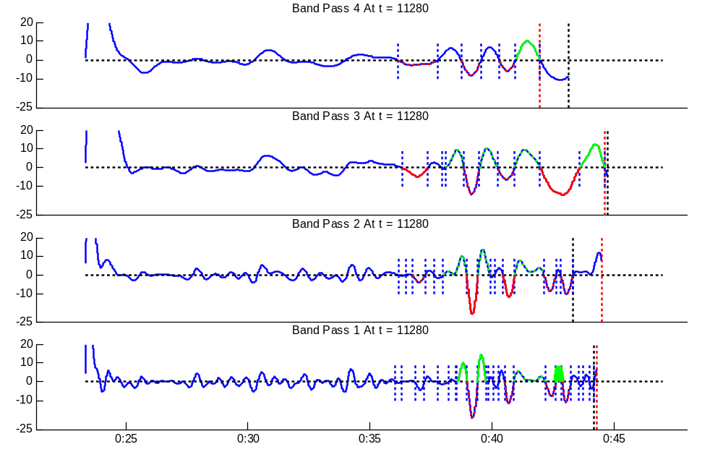
Figure 72: Bump Competition at t = 11280 samples
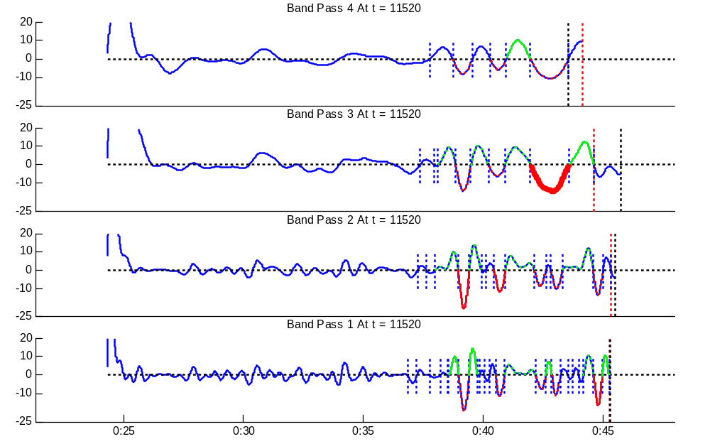
Figure 73: Bump Competition at t = 11520 samples

Bump Extension

The bump extension stage has two additional constraints in a realtime context, as compared to the offline case. The first is that a bump cannot extend back in time further than the end of the last event committed for final output in a prior window. This ensures that final output events cannot overlap. The second is that forward extension will be limited by the amount of low pass signal available. Because the delay on the low pass signal (on which extension is done) is much less than any of the band pass filter delays, there will always be at least approximately 2 minutes of low pass signal available after the end of a pre-extension bump candidate.

In some cases, a bump can be extended forward in time such that it now ends after the corresponding (accel or decel) commit index. In these cases, the extended bump candidate, if classified as a true event, will not be stable for the purposes of committing to final output. It should be noted that while the output of the bump competition is guaranteed to have no overlap between candidates of the same type, extended candidates do not have the same guarantee. In some cases, bump candidates will be extended into other bump candidates of the same type (i.e. in cases where a biphasic deceleration originally detected as two decel candidates becomes one decel candidate during the extension stage). These overlaps are resolved during the merging process.

Bump Classify
Bump classification is essentially a static process, and thus is little affected by a realtime context. One difference from the offline case is that there is more often no ensuing baseline that can be used as a reference (for input features fhrNext and varNext). In these cases, the values for fhrPrev and varPrev are used for fhrNext and varNext.

If a bump candidate is classified as a true event (either accel, gradual decel or abrupt decel), then it is added to a buffer of pre-merge events. This buffer contains events across all windows and is used when merging accels and decels to baselines for final output. This ensures that classification need not be done twice for the same bump candidate. It also ensures that events that have already been committed to final output are still considered in the merging process, as they may affect events that have not yet been committed to output.

Figure 74 shows the overall flow of accel/decel classification for a given signal window. The buffer of bump competition winners and the buffer of candidates classified as events (i.e. pre-merge accels and decels) are stored from window to window. These buffers ensure that events that have already been considered in previous windows are still taken into account for the purposes of bump competition and merging, respectively, while also ensuring that extension and classification are only done once for a given bump candidate.

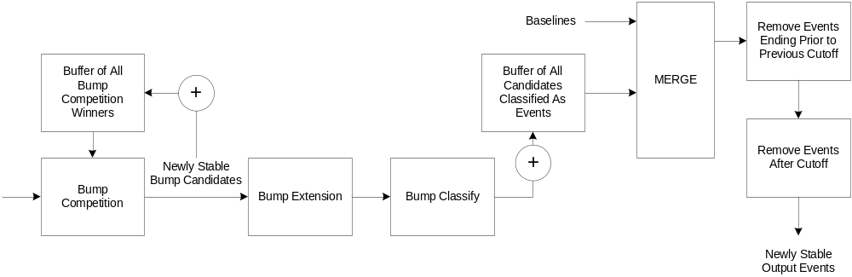
Figure 74: Realtime Accel/Decel flow

Dealing with Repaired Segments
Decel or Accel events that contain substantial amounts of repaired signal should be rejected, or at least labelled as ‘uninterpretable’. To determine whether an event has too much repair we consider several factors:

- The percentage of samples in the event that are repaired (P_{rep})
- The percentage of samples in the entry of the event that are repaired (PIN_{rep})
- The percentage of entry FHR shift accounted for by repaired samples (SIN_{rep})
- The percentage of samples in the exitof the event that are repaired (POUT_{rep})
- The percentage of exit FHR shift accounted for by repaired samples (SOUT_{rep})

The entry is defined as the signal at the start of the event required to reach 90% of the peak (for accels) or nadir (for decels), as measured in the lowpass domain. Similarily, the exit is defined as the signal at the end of the event from 90% of the peak or nadir, as measured in the lowpass domain. The entry and exit for a decel are shown graphically in Figure 75.
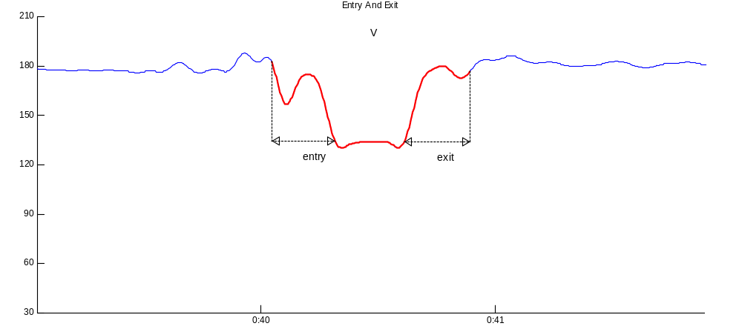
Figure 75: Event entry and exit

The entry of an event is deemed clean if all of the following conditions apply:
1) PIN_{rep} is < 50%
2) SIN_{rep} is < 50%
3) One of PIN_{rep} or SIN_{rep} is < 30%

Similarily, the exit of an event is deemed clean if all of the following conditions apply:
1) POUT_{rep} is < 50%
2) SOUT_{rep} is < 50%
3) One of POUT_{rep} or SOUT_{rep} is < 30%

An event is deemed clean if one of the following conditions apply:
1) Both the entry and exit are clean, and P_{rep} < 40%
2) One of the entry and exit is clean, and P_{rep} < 25%

Figure 76 shows an example of a decel that does not have a clean entry, but has a clean exit and just under 25% repair. This event would be kept as valid. Figure 77 shows a case where the decel is rejected because it only has a clean exit and also has greater than 25% repair. Figure 78 shows a case where there is more than 25% repair (but less than 40%) but because both the exit and entry are clean, the event is deemed valid.

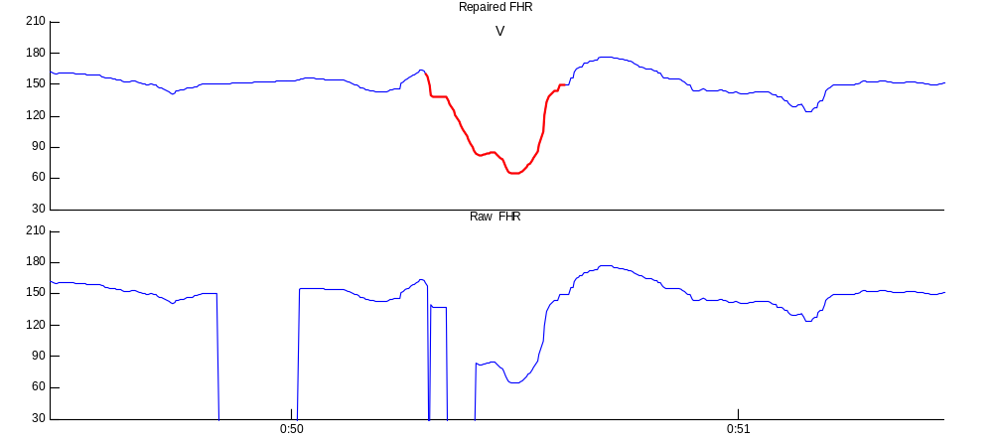
Figure 76: Event with clean exit and < 25% repair
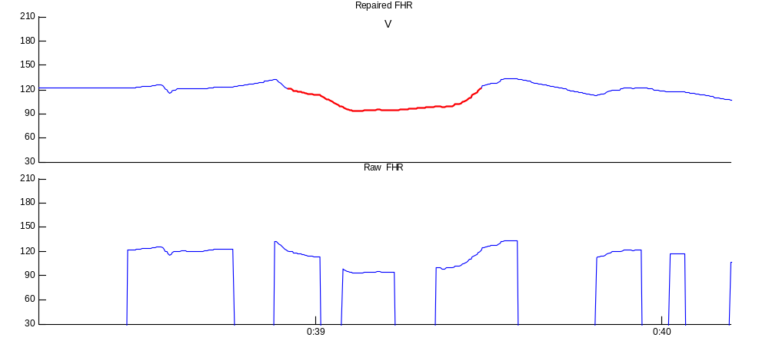
Figure 77: Rejected even with clean exit and > 25% repair
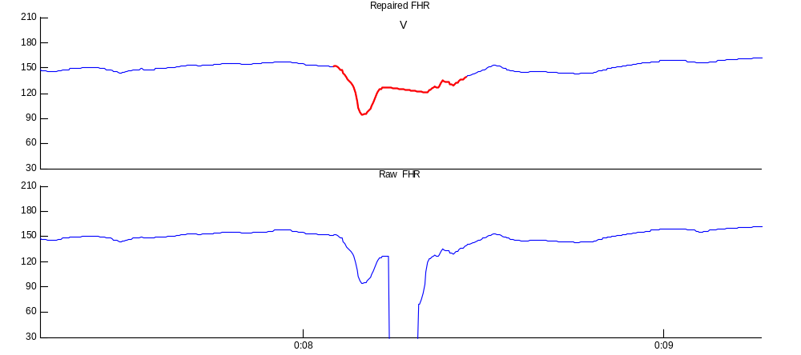
Figure 78: Event w/ between 25 and 40% repair but with clean exit and entry

Merging
Merging refers to the process of combining baselines with classified decels and accels, such that there is no overlap on final output events. Decels take precedence over accels and baselines, while accels take precedence over baselines.

Baselines that overlap accels or decels are truncated, and if the truncated baseline is less than 20 seconds in length then that truncated portion is discarded. Similarily, accels that overlap decels are truncated and truncated accels that are less than 10 seconds are discarded. Figure 79 shows an example of final accels, decels, and baselines and the merged output, with decels shown in red, accels in green, and baselines as black lines. One of the two accels is truncated to a length of less than 10 seconds and is discarded, while the other accel is truncated but remains as part of the output. Several baselines are overwritten by decels, while others are only truncated.

In cases where there are overlapping events of the same type (this can sometimes happen when accels or decels are extended), then the later event takes precedence over the earlier event.

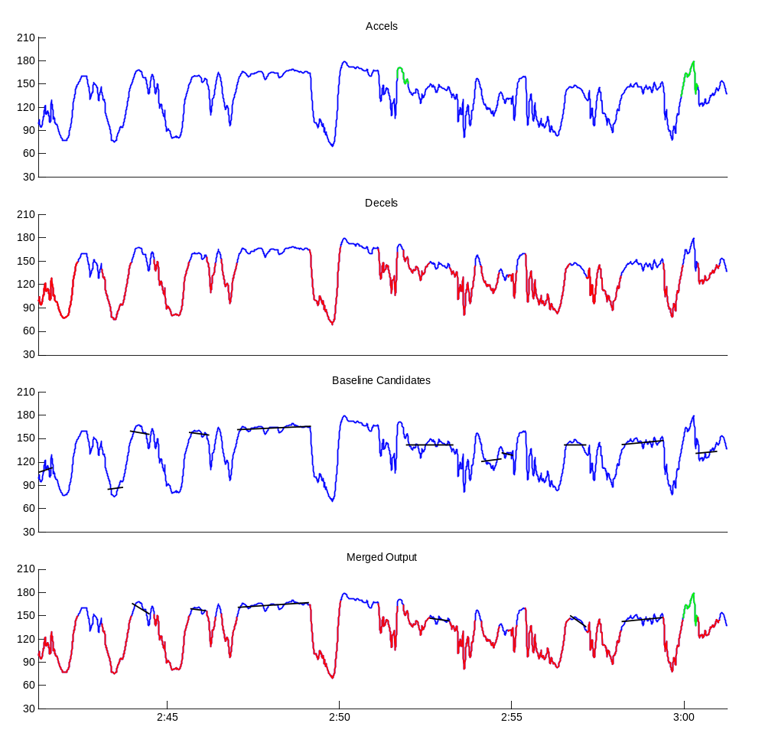
Figure 79: Merged Output
Because of the bump extension stage, there can be classified bumps of the same type overlapping each other. In these cases, later events overwrite prior events.

Realtime Considerations
The merging process ensures that output events are not overlapping. It also ensures that merged output events are stable – that they will not change based on future input. The first step of the merge is done as in the offline case. Decels take precedence over accels and baselines, and accels take precedence over baselines. Overlapping events are truncated based on precedence. In cases where overlapping events are of the same type (as is possible due to bump extension), the event that ends later takes precedence over the earlier event.

To ensure that a merged output event is stable, it must end before an appropriate cutoff index. Separate cutoff indexes exist for baselines, accels and decels.

Cutoff Index
The baseline cutoff index indicates the sample index at which any baseline to be output in the current window will not change based on future events. This is equivalent to saying that the baseline cannot possibly have any overlap with an accel or decel from an ensuing window. A baseline ending before the baseline cutoff index can be deemed stable and be committed to final output.

To determine the earliest point at which a decel could start in an ensuing window, we consider the zero crossings of all band pass signals and the overall decel commit index. The earliest positive-to-negative zero crossing (i.e. beginning of decel candidate) whose ensuing negative-to-positive zero crossing (i.e. end of decel candidate) occurs after the overall decel commit index is the earliest point at which a decel from a given band could start in an ensuing window. Any decel candidate that ends before the decel commit index would have already been considered during the merge in the present window. This is shown more clearly in Figure 80. The overall decel commit index is shown as a red dotted line while the per-band earliest possible decel starts are shown as black dotted lines (note that these are equal for band 4). The earliest possible decel start point for the purposes of computing the baseline cutoff index is then taken as the earliest of these per-band earliest decel start points. In most cases this will be close to the overall decel commit index.

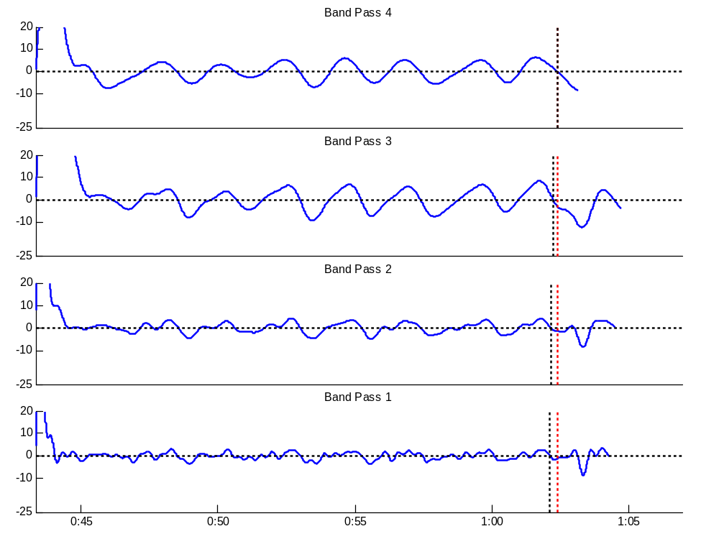
Figure 80: Earliest Possible Decel Start in Ensuing Window
The earliest possible accel starting point in an ensuing window is calculated in an analogous way. This is shown in Figure 81. The overall accel commit index is shown as a dotted red line while the per-band earliest possible accel start points are shown as dotted black lines.

The baseline cutoff index is equal to the minimum of the earliest possible decel start point in an ensuing window and the earliest possible accel start point in an ensuing window. Any baseline in the merged output that ends after the baseline cutoff cannot be committed for final output.

It should be noted that the determination of the earliest possible decel or accel start point in an ensuing window does not take into consideration the potential that a bump could be extended backwards in time. Consideration for any possible extension would require a substantial delay in final output of baselines. In order to ensure that there are no overlapping events, a bump candidate can not be extended back in time past the point of an event (baseline, accel or decel) that has already been committed for final output.

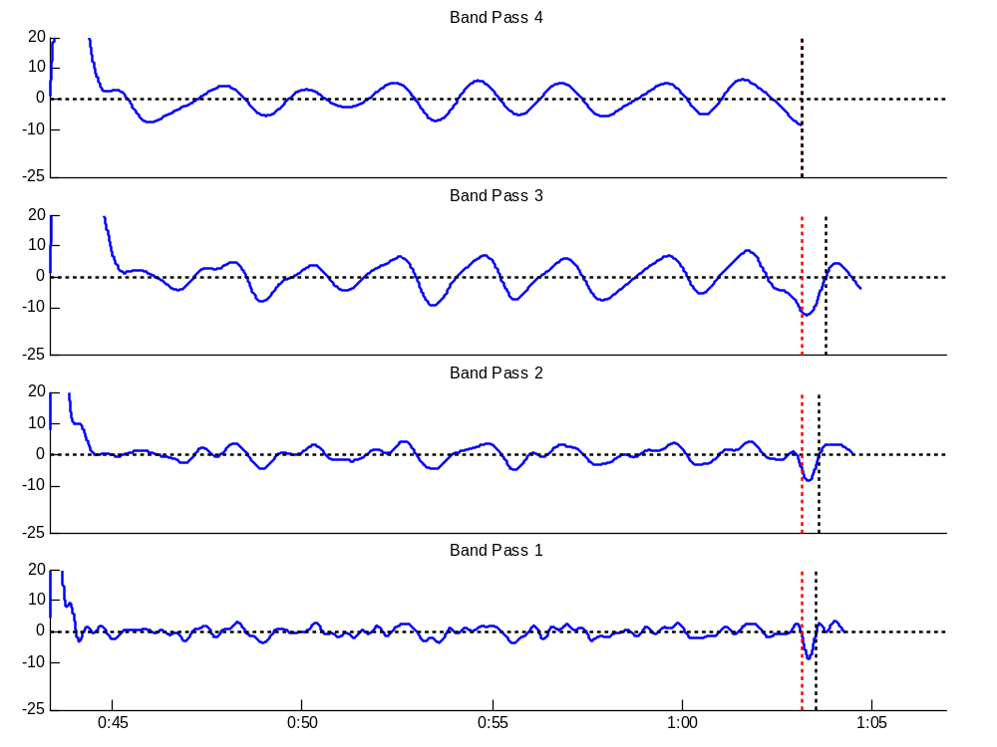
Figure 81: Earliest Possible Accel Start Point in Ensuing Window

The accel cutoff index is equal to the earliest possible decel start point in an ensuing window. Any accel in the merged output that ends after the accel cutoff cannot yet be committed for final output.

The decel cutoff index is equal to the overall decel commit index. Since decels take precedence over baseline and accels in the merge process, only future decels need to be considered when considered stability for final output. The only way in which a merged decel can finish after the decel cutoff is if the non-extended decel finished before (or at) the decel commit index and the decel was extended to a point past the decel commit index. In these cases we must wait for future signal before committing a decel to final output (this includes the case where a decel is extended to the end of available low pass signal).

Figure 82 to Figure 85 show the merging process and final output for 4 consecutive windows. Overall output (over all windows) is shown for accels, decels and baseline and the merged output in each figure, but only new events are shown in solid colours.

Solid green lines in the ‘Accels’ portions of the figures represent newly stable accel candidates classified as true accels, while the dotted green lines represent accels classified in previous windows. The dotted vertical black line indicates the accel cutoff index. Similarily, solid red lines in the ‘Decels’ portions represent newly stable decels classified as true decels, while dotted red lines represent decels classified in prior windows. The dotted vertical black line represents the decel cutoff index.

Baselines that are newly final are shown as a solid black line, while baselines detected in prior windows are shown as dotted black lines. The dotted vertical black line in the ‘Baseline’ portions of the figures denotes the baseline cutoff index.

For the merged output, events marked as solid lines (black for baseline, green for accel, red for decel) indicate those committed to output in the current window. Dotted events represent events already committed to output in prior windows. We can see that newly stable accels and final baselines are not necessarily ready for commitment to final output (see Figure 83 for example of accel and Figure 82 for example of baseline).

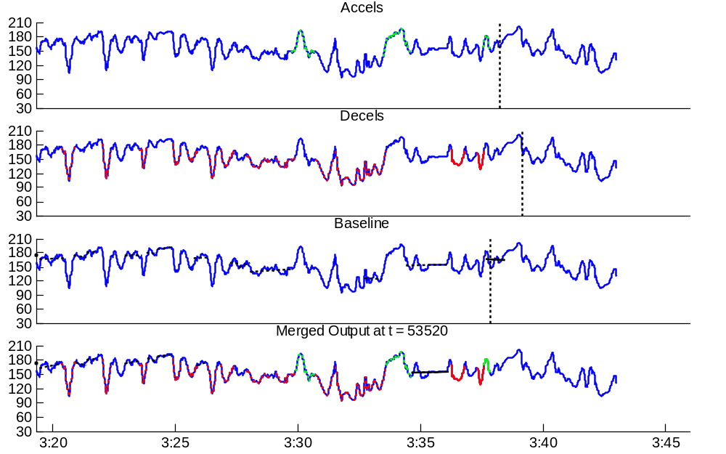
Figure 82: Real time Merged Output at t= 53520 samples

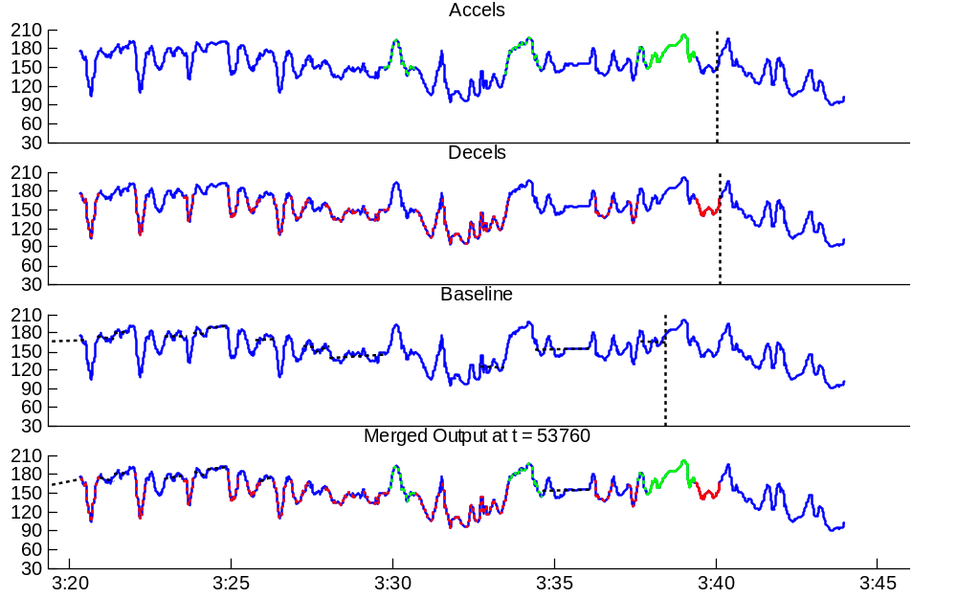
Figure 83: Real time Merged Output at t = 53760 samples
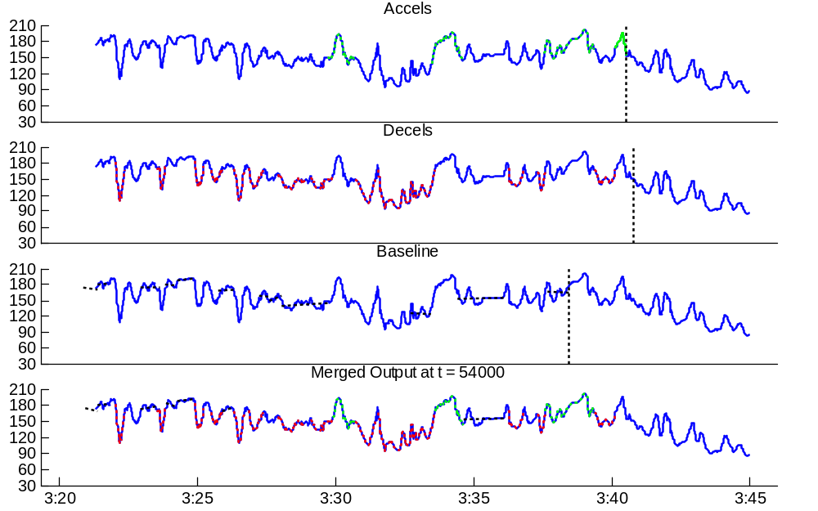
Figure 84: Real time Merged Output at t = 54000 samples
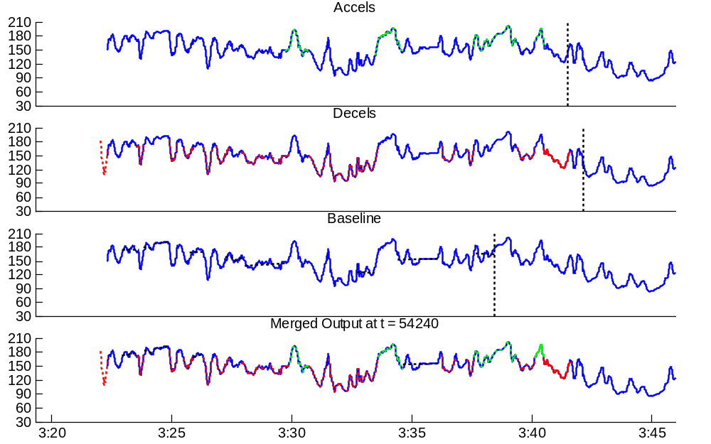
Figure 85: Real time Merged Output at t = 54240 samples

